CNN for TRPS fits

LeNet and Sparse Densenet – comparison of performances on experimental spectra

|  |  |  |  |  |  |
| --- | --- | --- | --- | --- | --- |
| 2 | November 2021 | CTF1 | 10 mW | Pb 4f | 20211125_TR CTF1 Pb 10 mW_0001_2 |

Number of peaks forced to 2

|  |  |  |
| --- | --- | --- |
|  | LeNet | Sparse_densenet |
| |  |  | | --- | --- | | Time agregation number | 10 | | Time moving average window (us) | 1 | | Energy Savitzky-Golay window (meV) | 100 | | Energy Savitzky-Golay order | 3 | |  |  |
| |  |  | | --- | --- | | Time agregation number | 10 | | Time moving average window (us) | 1 | | Energy Savitzky-Golay window (meV) | 300 | | Energy Savitzky-Golay order | 3 | |  |  |
| |  |  | | --- | --- | | Time agregation number | 20 | | Time moving average window (us) | 2 | | Energy Savitzky-Golay window (meV) | 100 | | Energy Savitzky-Golay order | 3 | |  |  |

|  |  |  |  |  |  |
| --- | --- | --- | --- | --- | --- |
| 4 | November 2021 | CTF1 | 10 mW | I 3d 5/2 | 20211125_TR CTF1 I3d 10 mW_0001_2 |

Number of peaks forced to 2

|  |  |  |
| --- | --- | --- |
|  | LeNet | Sparse_densenet |
| |  |  | | --- | --- | | Time agregation number | 10 | | Time moving average window (us) | 1 | | Energy Savitzky-Golay window (meV) | 75 | | Energy Savitzky-Golay order | 3 | |  |  |
| |  |  | | --- | --- | | Time agregation number | 10 | | Time moving average window (us) | 1 | | Energy Savitzky-Golay window (meV) | 100 | | Energy Savitzky-Golay order | 3 | |  |  |
| |  |  | | --- | --- | | Time agregation number | 20 | | Time moving average window (us) | 1 | | Energy Savitzky-Golay window (meV) | 75 | | Energy Savitzky-Golay order | 3 | |  |  |

|  |  |  |  |  |  |
| --- | --- | --- | --- | --- | --- |
| 4 | November 2021 | CTF1 | 10 mW | I 3d 5/2 | 20211125_TR CTF1 I3d 10 mW_0001_2 |

Number of peaks forced to 1

|  |  |  |  |  |  |  |  |  |  |  |
| --- | --- | --- | --- | --- | --- | --- | --- | --- | --- | --- |
| |  |  | | --- | --- | | Time agregation number | 10 | | Time moving average window (us) | 1 | | Energy Savitzky-Golay window (meV) | 75 | | Energy Savitzky-Golay order | 3 | |  |  |
| |  |  | | --- | --- | | Time agregation number | 10 | | Time moving average window (us) | 1 | | Energy Savitzky-Golay window (meV) | 100 | | Energy Savitzky-Golay order | 3 | |  |  |
| |  |  | | --- | --- | | Time agregation number | 20 | | Time moving average window (us) | 1 | | Energy Savitzky-Golay window (meV) | 75 | | Energy Savitzky-Golay order | 3 | |  |  |
| |  |  | | --- | --- | | Time agregation number | 5 | | Time moving average window (us) | 1 | | Energy Savitzky-Golay window (meV) | 75 | | Energy Savitzky-Golay order | 3 | |  |  |

# Training on database including more noise

|  |  |  |
| --- | --- | --- |
|  | Smooth database | Noisy database |
|  | Noise amplitude: [-0.01; 0.01] | Noise amplitude: [-0.5; 0.5] |
| Two examples of synthetic spectra from both databases  Amplitude of the peaks: [0.05; 1.005] |  |  |
| Evolution of total loss over training |  |  |
| Examples of test fits |  |  |

|  |  |  |  |  |  |
| --- | --- | --- | --- | --- | --- |
| 2 | November 2021 | CTF1 | 10 mW | Pb 4f | 20211125_TR CTF1 Pb 10 mW_0001_2 |

Number of peaks forced to 2

|  |  |  |  |  |  |  |  |  |  |  |
| --- | --- | --- | --- | --- | --- | --- | --- | --- | --- | --- |
| |  |  | | --- | --- | | Time agregation number | 10 | | Time moving average window (us) | 1 | | Energy Savitzky-Golay window (meV) | 100 | | Energy Savitzky-Golay order | 3 | |  |  |
| |  |  | | --- | --- | | Time agregation number | 10 | | Time moving average window (us) | 1 | | Energy Savitzky-Golay window (meV) | 300 | | Energy Savitzky-Golay order | 3 | |  |  |

|  |  |  |  |  |  |
| --- | --- | --- | --- | --- | --- |
| 2 | November 2021 | CTF1 | 10 mW | Pb 4f | 20211125_TR CTF1 Pb 10 mW_0001_2 |

Number of peaks forced to 4

|  |  |  |  |  |  |  |  |  |  |  |
| --- | --- | --- | --- | --- | --- | --- | --- | --- | --- | --- |
| |  |  | | --- | --- | | Time agregation number | 10 | | Time moving average window (us) | 1 | | Energy Savitzky-Golay window (meV) | 100 | | Energy Savitzky-Golay order | 3 | |  |  |
| |  |  | | --- | --- | | Time agregation number | 10 | | Time moving average window (us) | 1 | | Energy Savitzky-Golay window (meV) | 300 | | Energy Savitzky-Golay order | 3 | |  |  |

Ideas to go further

* Limit the possibility to have a subsequent fit where a peak has been found: erase the residuals
* Increase noise level in database to improve fit quality
* Directly detect more peaks

|  |  |
| --- | --- |
| Smooth training database | Noisy training database |
|  |  |

|  |  |  |  |  |  |
| --- | --- | --- | --- | --- | --- |
| 2 | November 2021 | CTF1 | 10 mW | Pb 4f | 20211125_TR CTF1 Pb 10 mW_0001_2 |

|  |  |
| --- | --- |
| Time agregation number | 10 |
| Time moving average window (us) | 1 |
| Energy Savitzky-Golay window (meV) | 100 |
| Energy Savitzky-Golay order | 3 |

Number of peaks forced to 2

|  |  |  |
| --- | --- | --- |
|  | Smooth training database | Noisy training database |
| Sparse densenet |  |  |
| Lenet |  |  |

Number of peaks forced to 4

|  |  |  |
| --- | --- | --- |
|  | Smooth training database | Noisy training database |
| Sparse densenet |  |  |
| Lenet |  |  |

# Three noise levels in the training database

**Three databases generated with increasing noise level**

|  |  |  |
| --- | --- | --- |
| Database A (ML_models_  large_database_v1) | Size of total database: 1412339  Size of training database: 1129871  Size of validation database: 141234  Size of test database: 141234 | Noise: random uniform in [-0.01; 0.01]  Peaks amplitude: random uniform in [0.3; 1.9] |

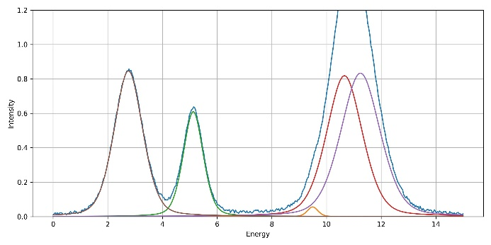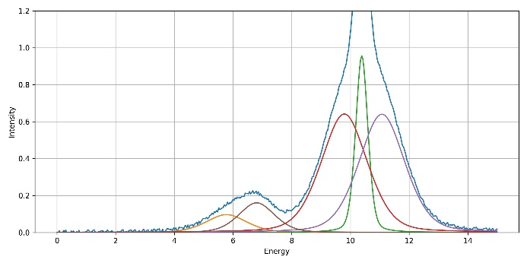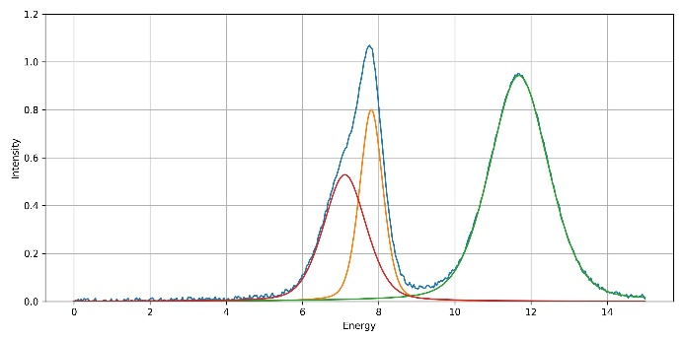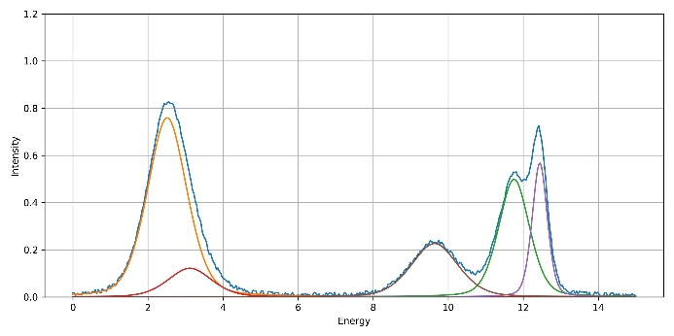

|  |  |  |
| --- | --- | --- |
| Database B (ML_models_  large_database_noisy) | Size of total database: 1411895  Size of training database: 1129516  Size of validation database: 141189  Size of test database: 141190 | Noise: random uniform in [-0.05; 0.05]  Peaks amplitude: random uniform in [0.3;1.9] |

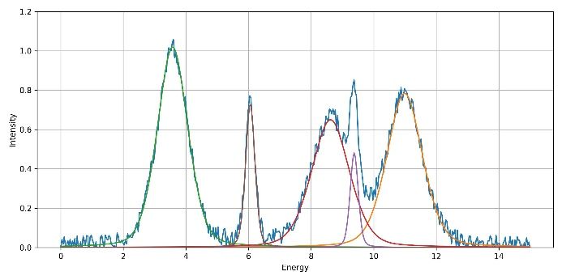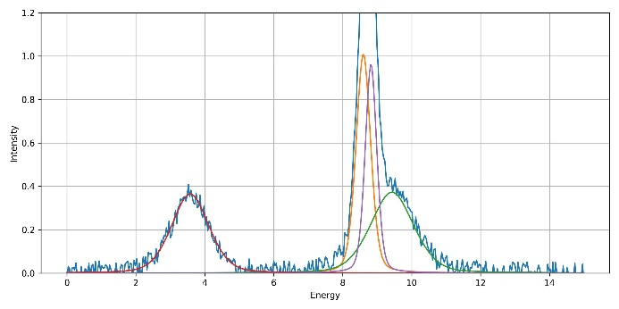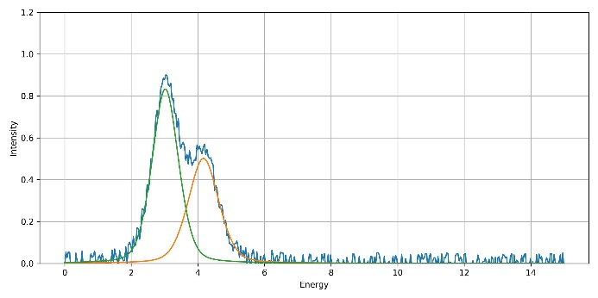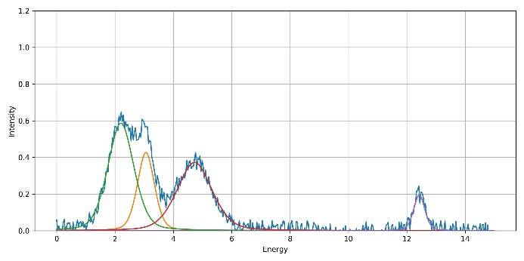

|  |  |  |
| --- | --- | --- |
| Database C (ML_models_  large_database_noisy_v1) | Size of total database: 1412632  Size of training database: 1130105  Size of validation database: 141263  Size of test database: 141264 | Noise: random uniform in [-0.2; 0.2]  Peaks amplitude: random uniform in [0.3;1.9] |

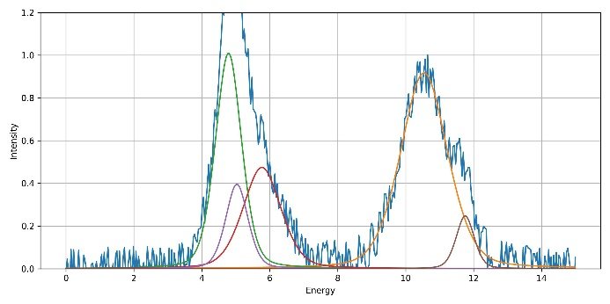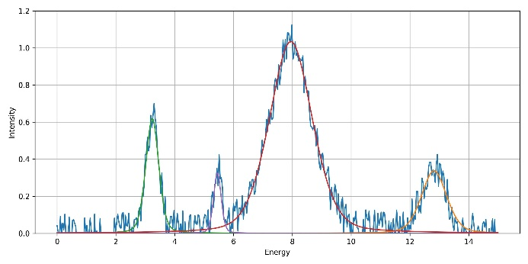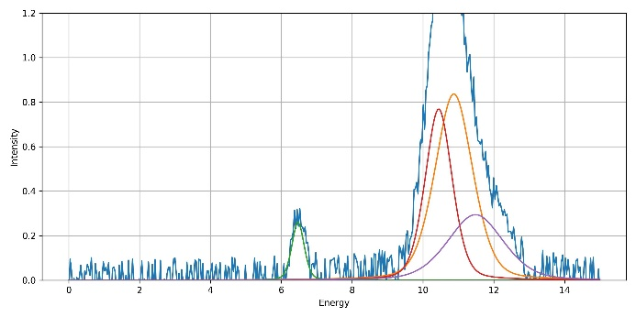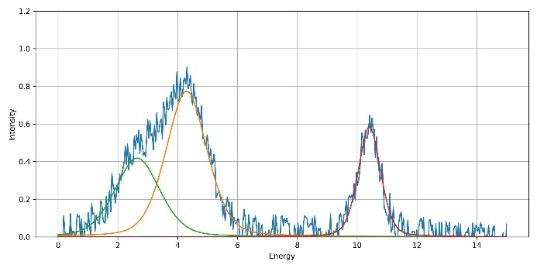

**Training and validation results:**

Database: ML_models_large_database_v1 (size of total database: 1 412 339)

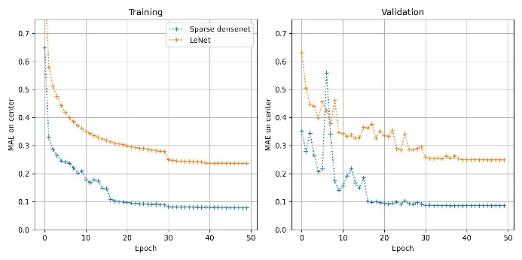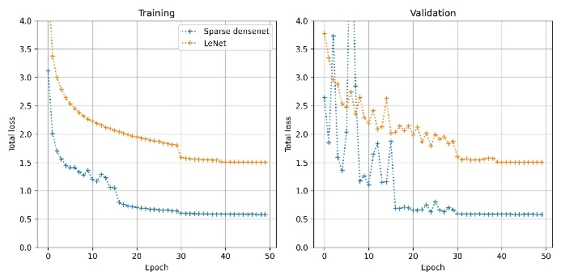

Database: ML_models_large_database_noisy (size of total database: 1 411 895)

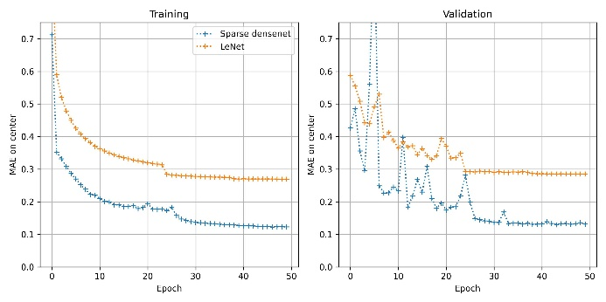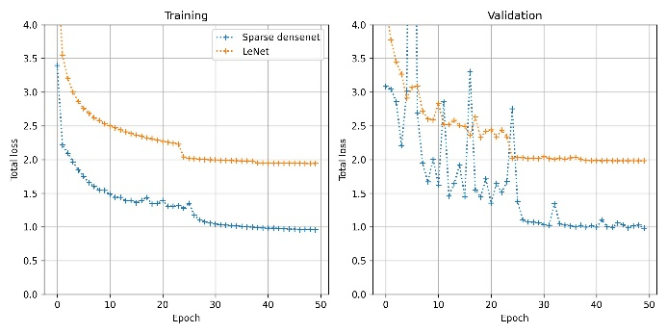

Database: ML_models_large_database_noisy_v1 (size of total database: 1 412 632)

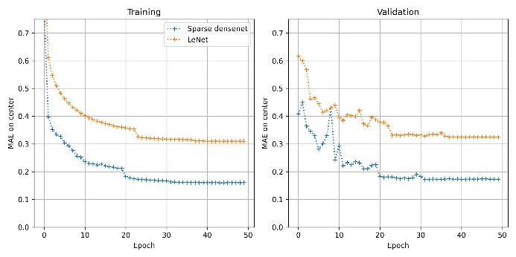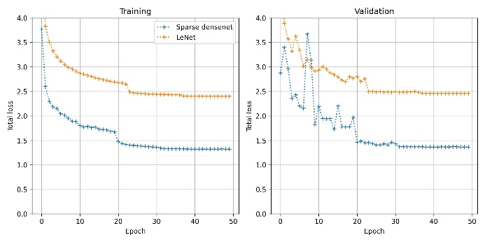

For Sparse densenet, the final loss on peak position rises from approx. 0.09 eV with the original low noise database, to approx. 0.16 eV with the noisiest. Still acceptable.

**Test results:**

|  |  |  |
| --- | --- | --- |
|  | Sparse densenet | LeNet |
| Database A | MAE on center: 0.09  MAE on width: 0.02  MAE on amplitude: 0.01  MAE on peak number: 0.03 | MAE on center: 0.25  MAE on width: 0.05  MAE on amplitude: 0.03  MAE on peak number: 0.10 |

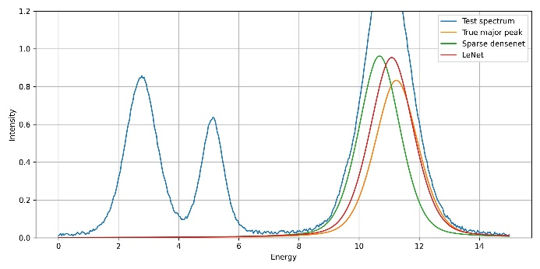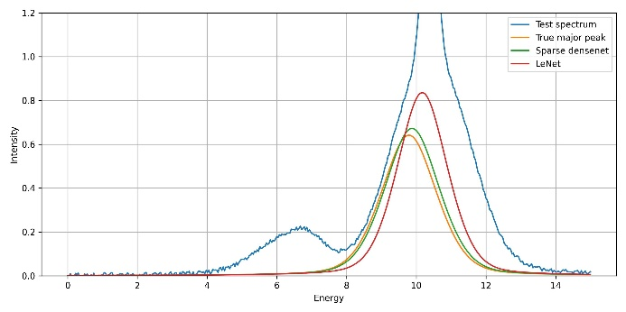

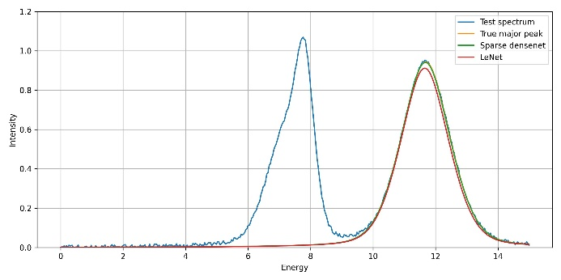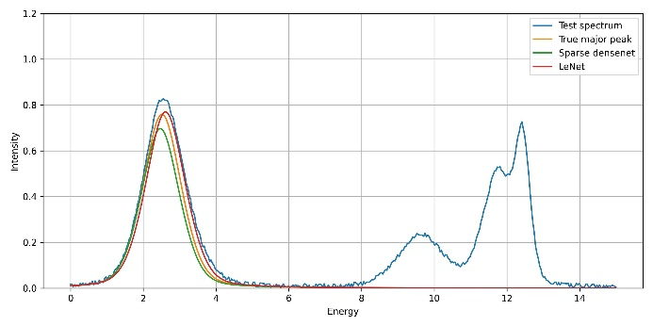

|  |  |  |
| --- | --- | --- |
|  | Sparse densenet | LeNet |
| Database B | MAE on center: 0.13  MAE on width: 0.03  MAE on amplitude: 0.02  MAE on peak number: 0.06 | MAE on center: 0.28  MAE on width: 0.06  MAE on amplitude: 0.04  MAE on peak number: 0.17 |

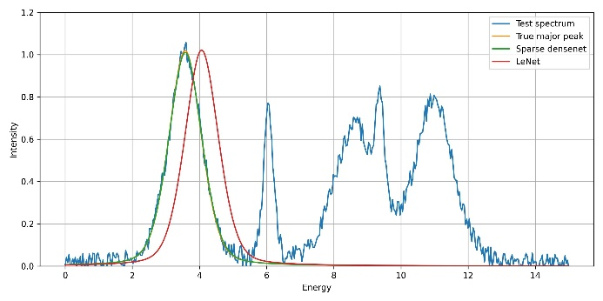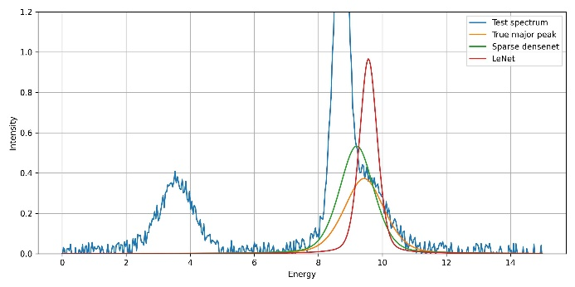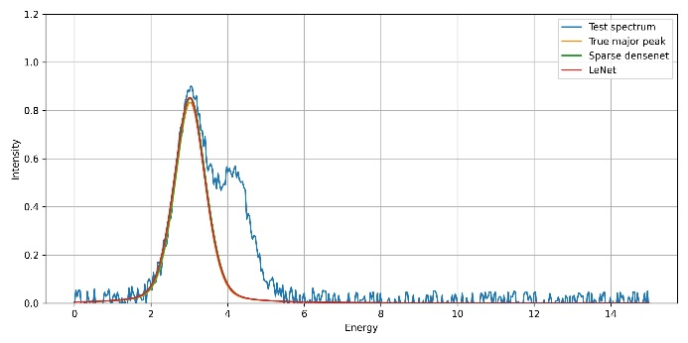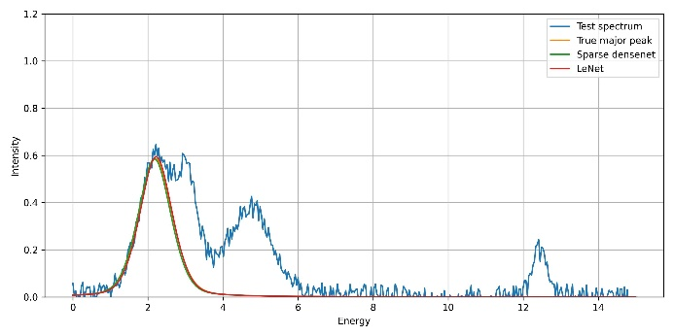

|  |  |  |
| --- | --- | --- |
|  | Sparse densenet | LeNet |
| Database C | MAE on center: 0.17  MAE on width: 0.04  MAE on amplitude: 0.03  MAE on peak number: 0.09 | MAE on center: 0.33  MAE on width: 0.08  MAE on amplitude: 0.04  MAE on peak number: 0.23 |

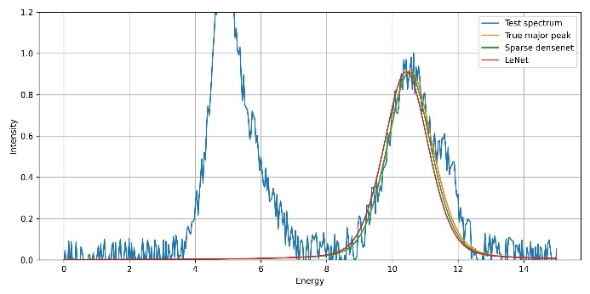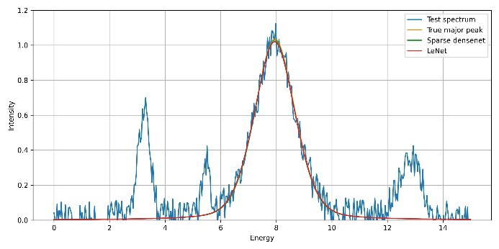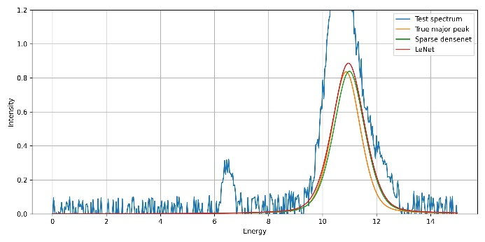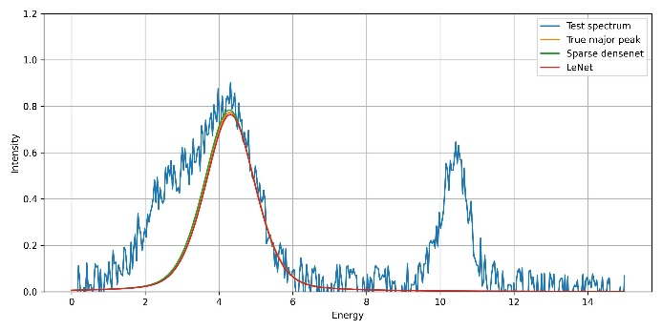

Change in performances is low.

**Iterative fitting results:**

Number of fitted contributions is designed by first CNN fit.

**Database A**

Sparse densenet

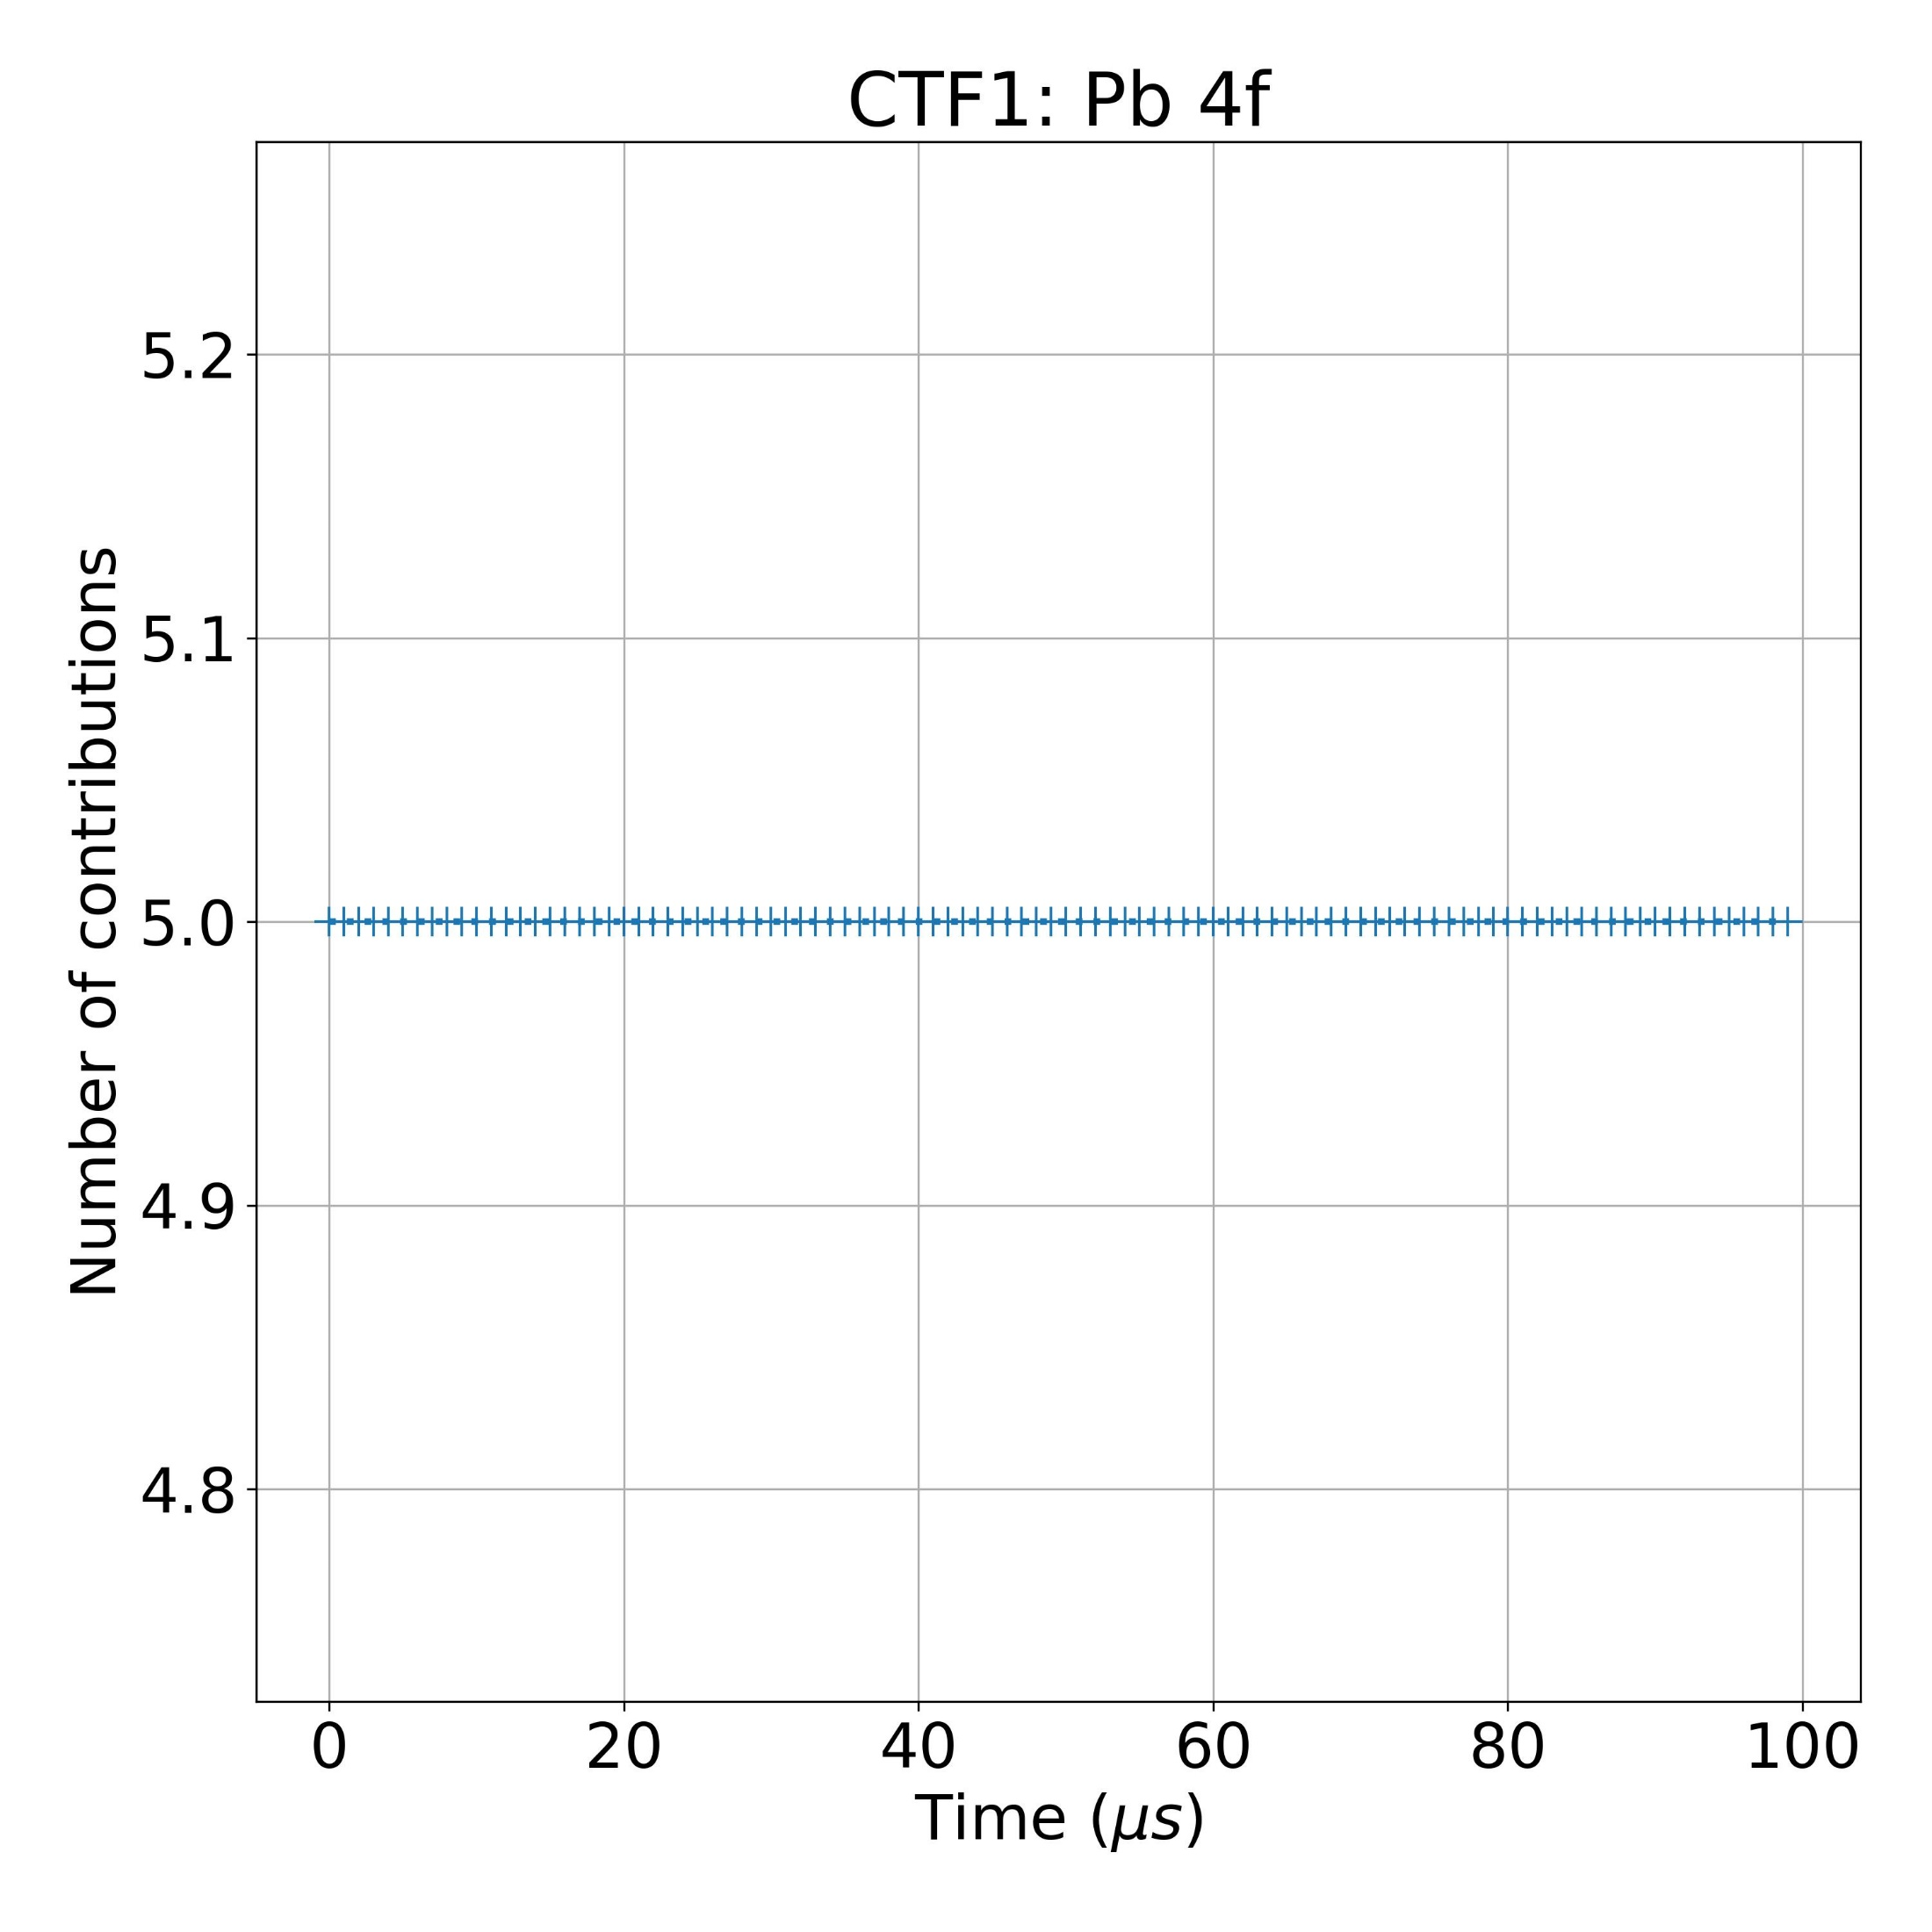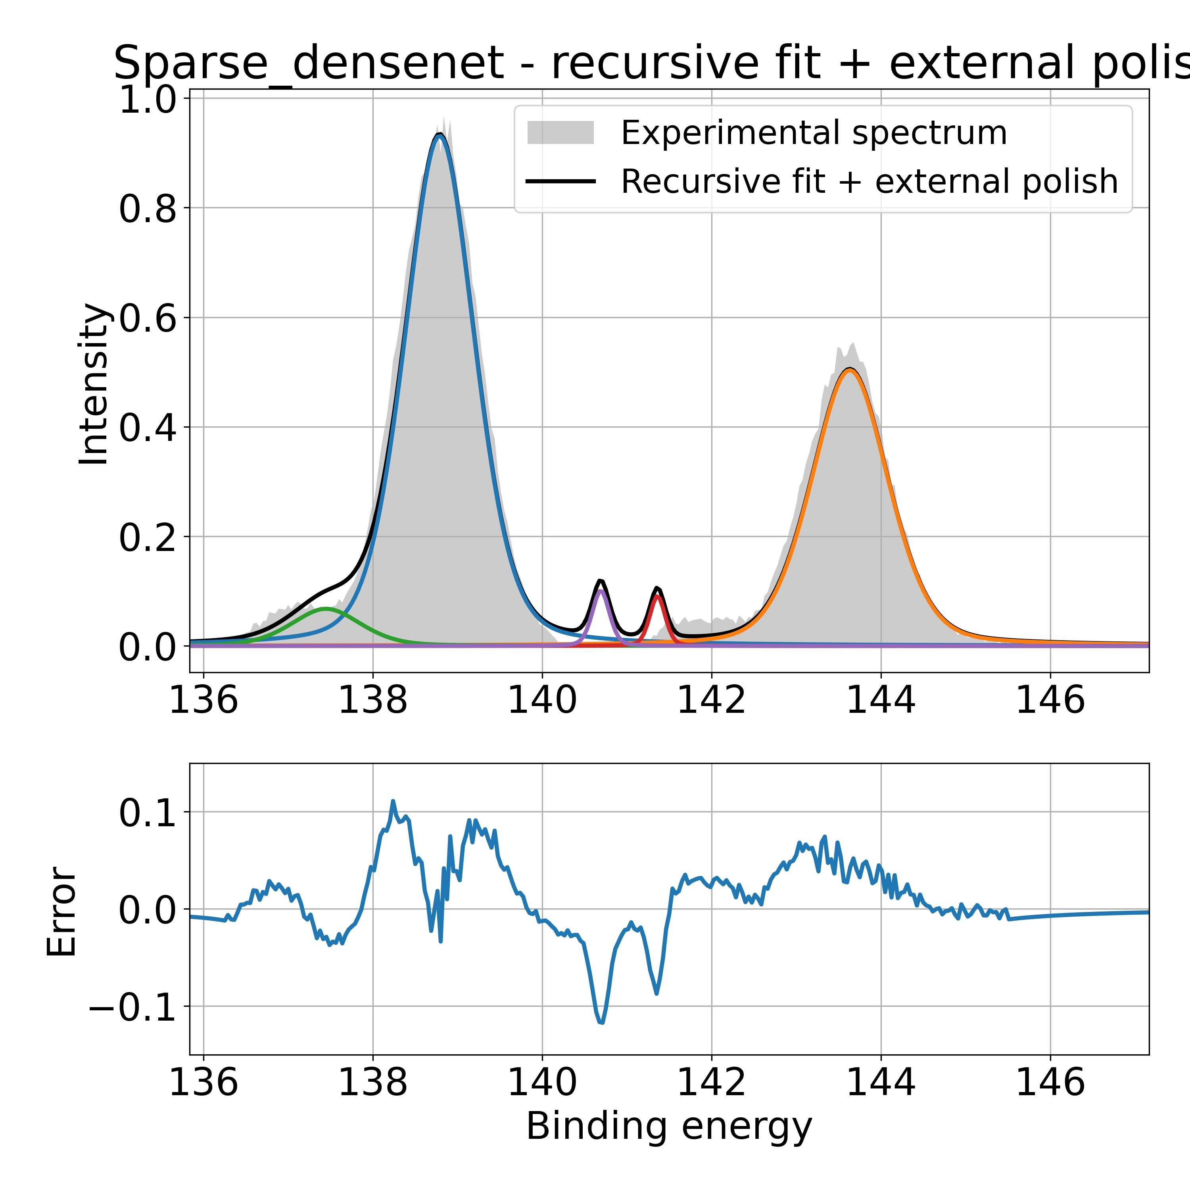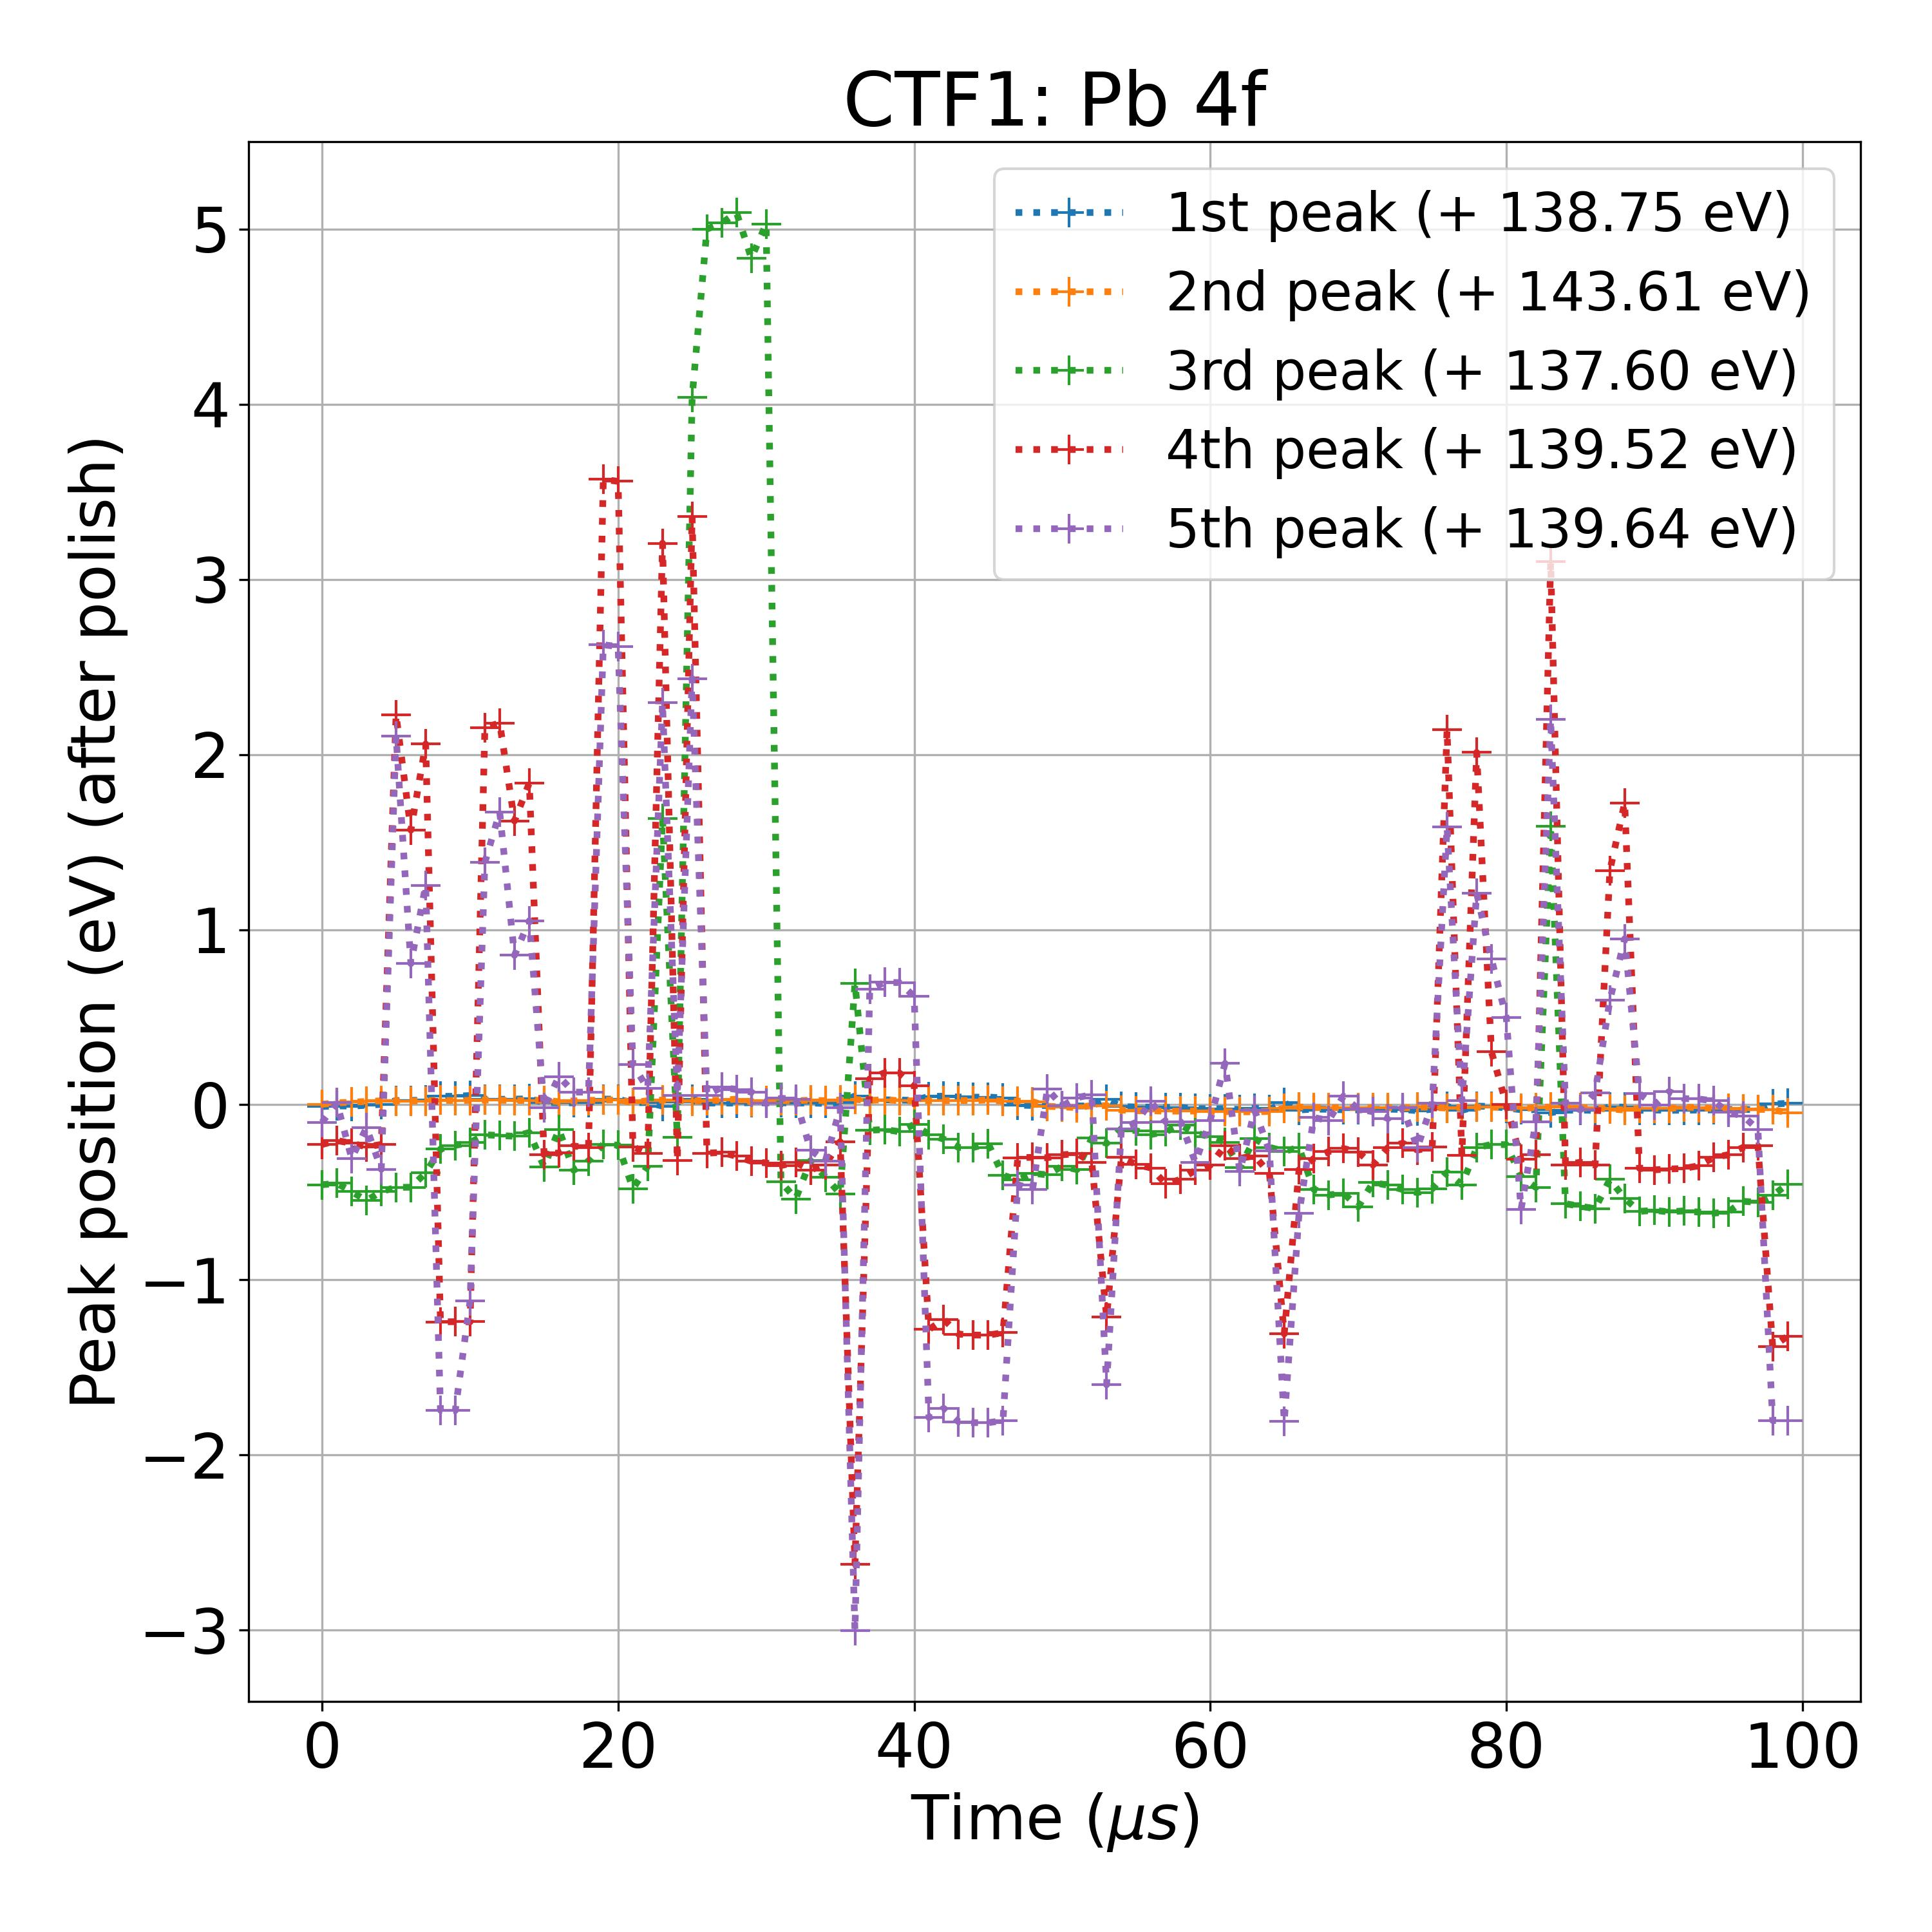

LeNet

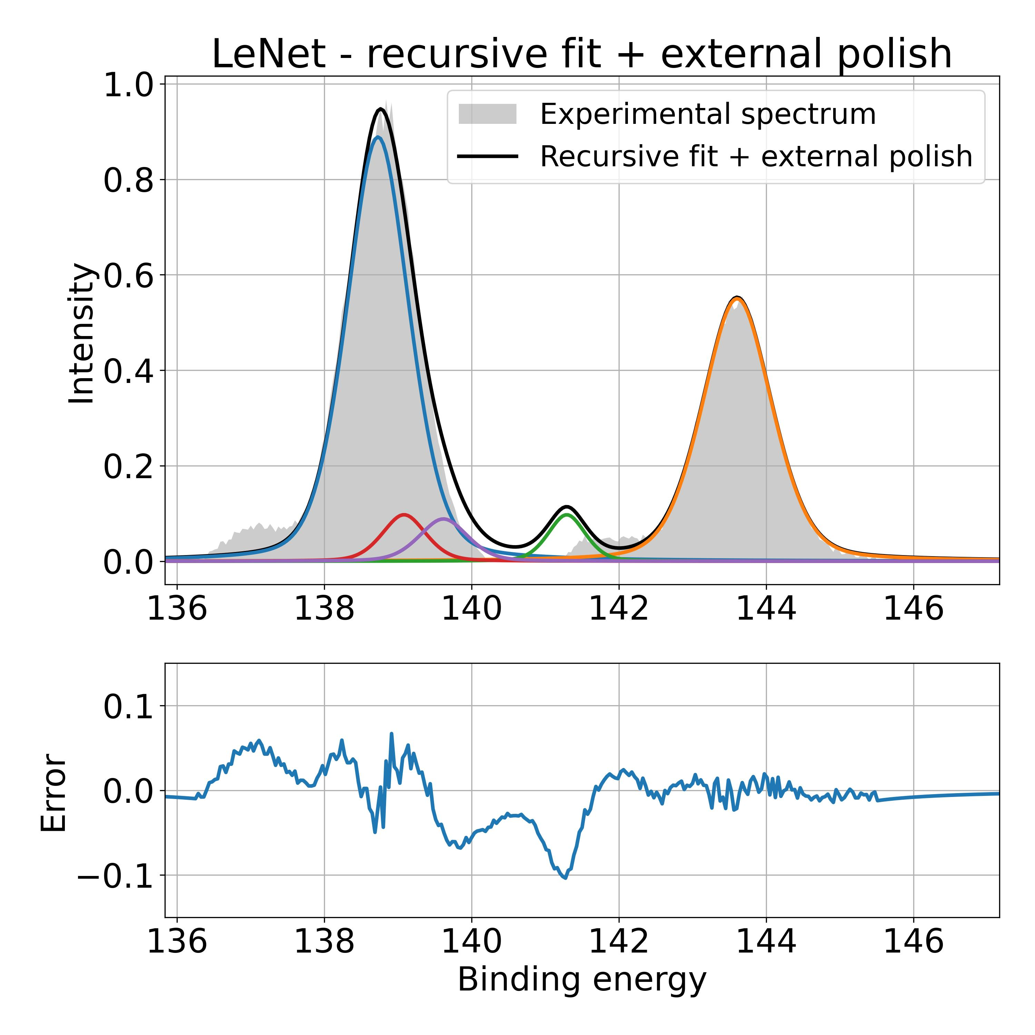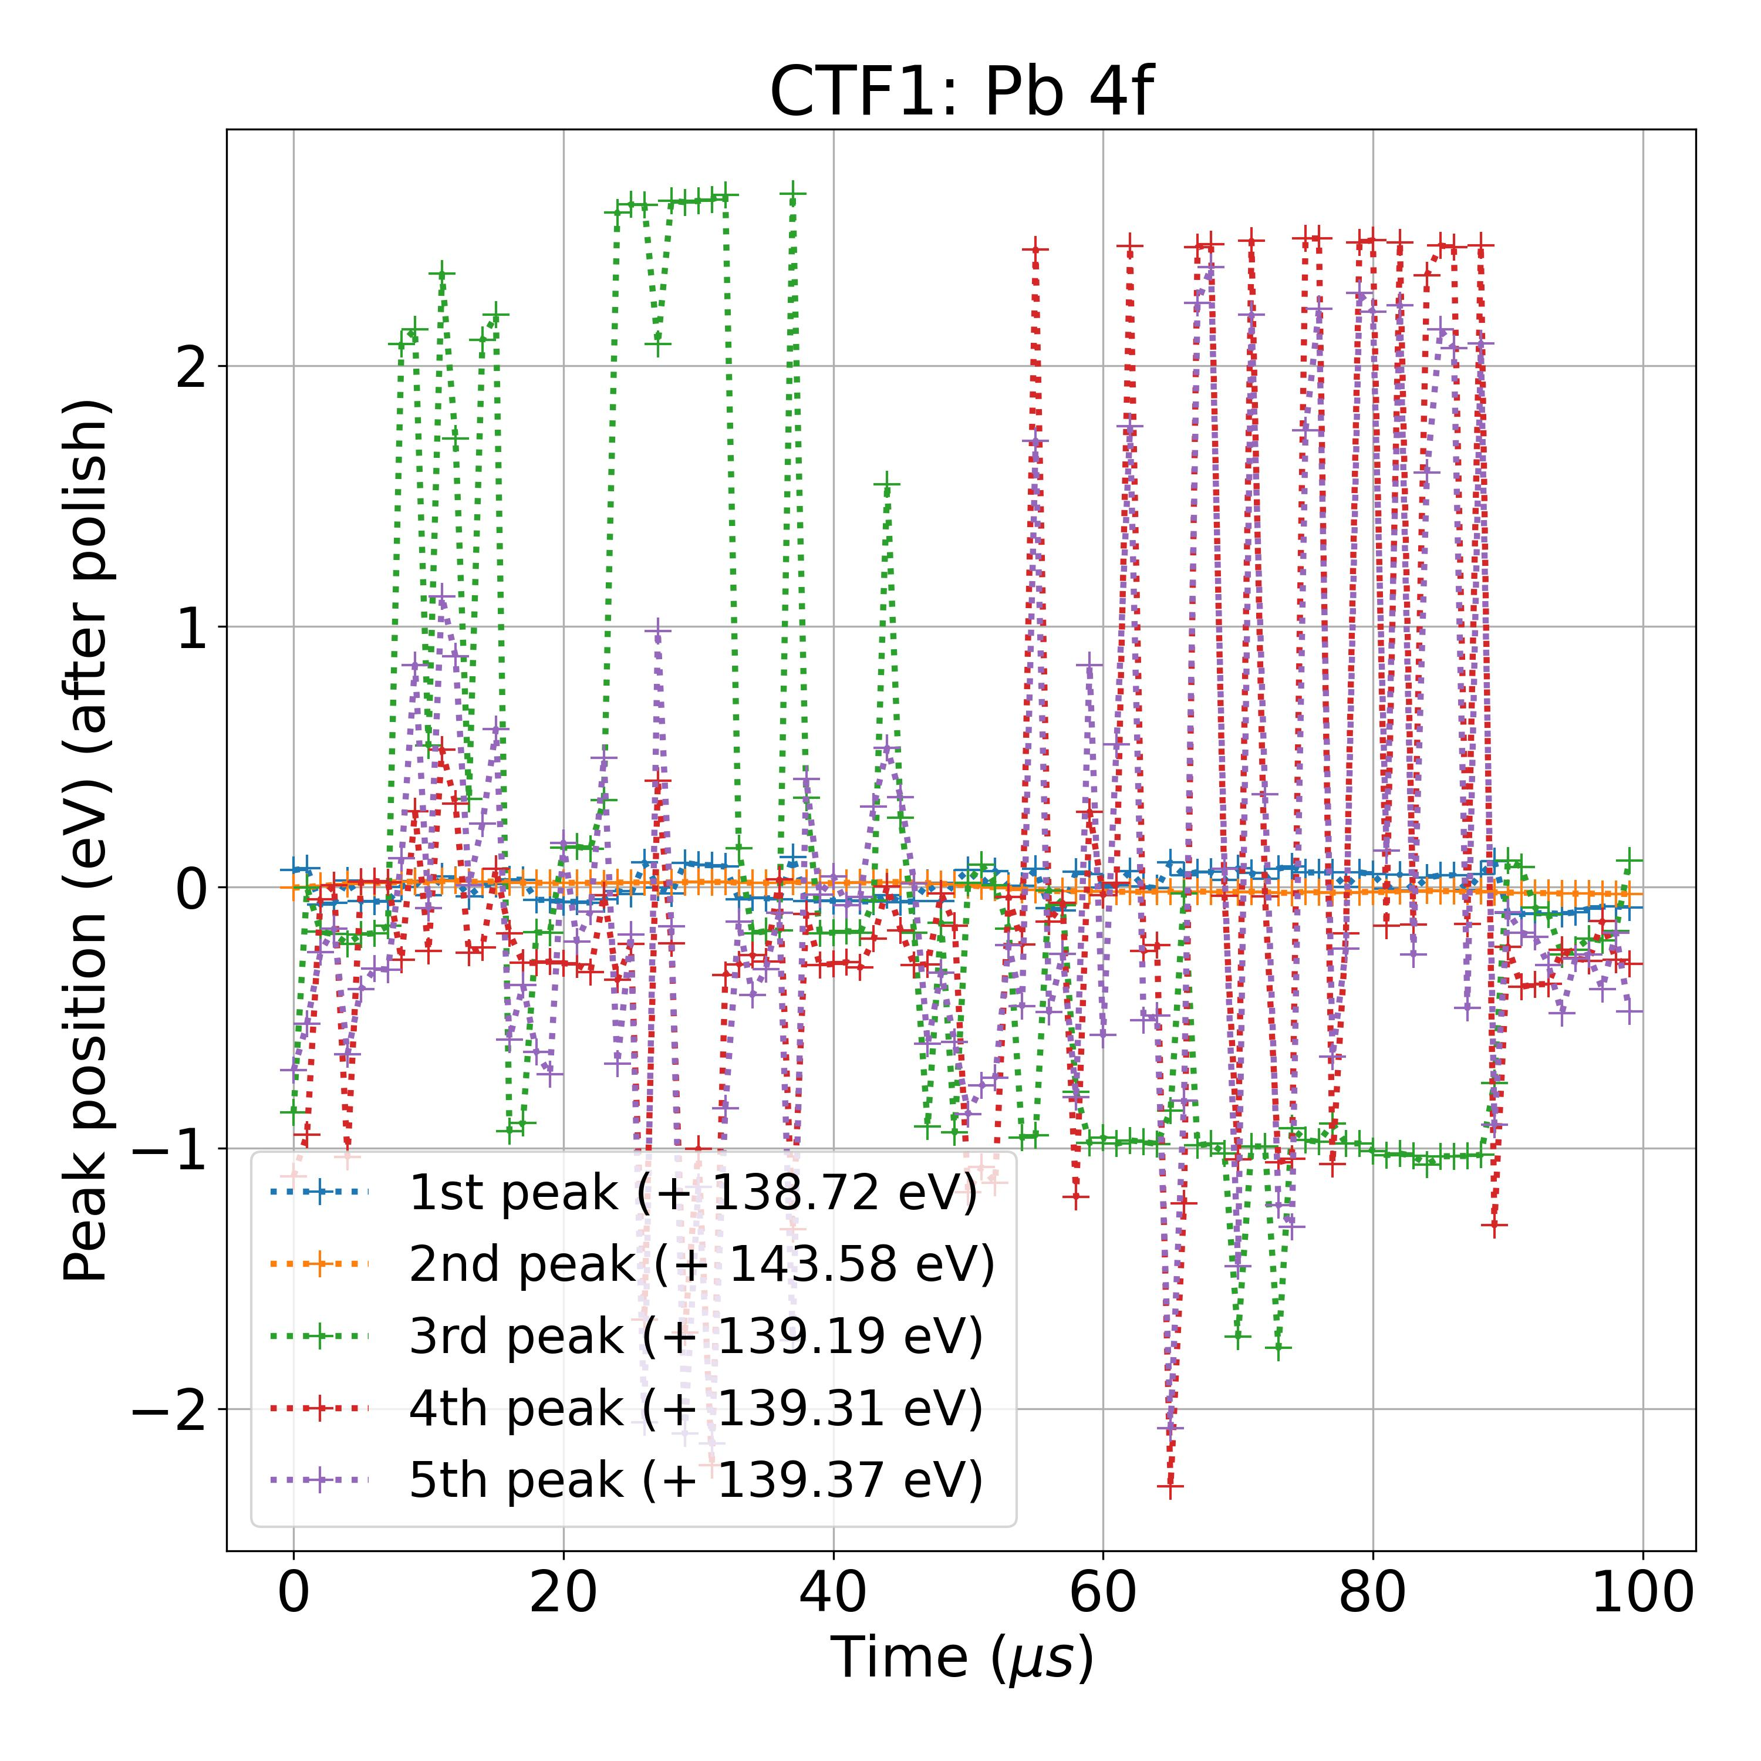

**Database B**

Sparse densenet

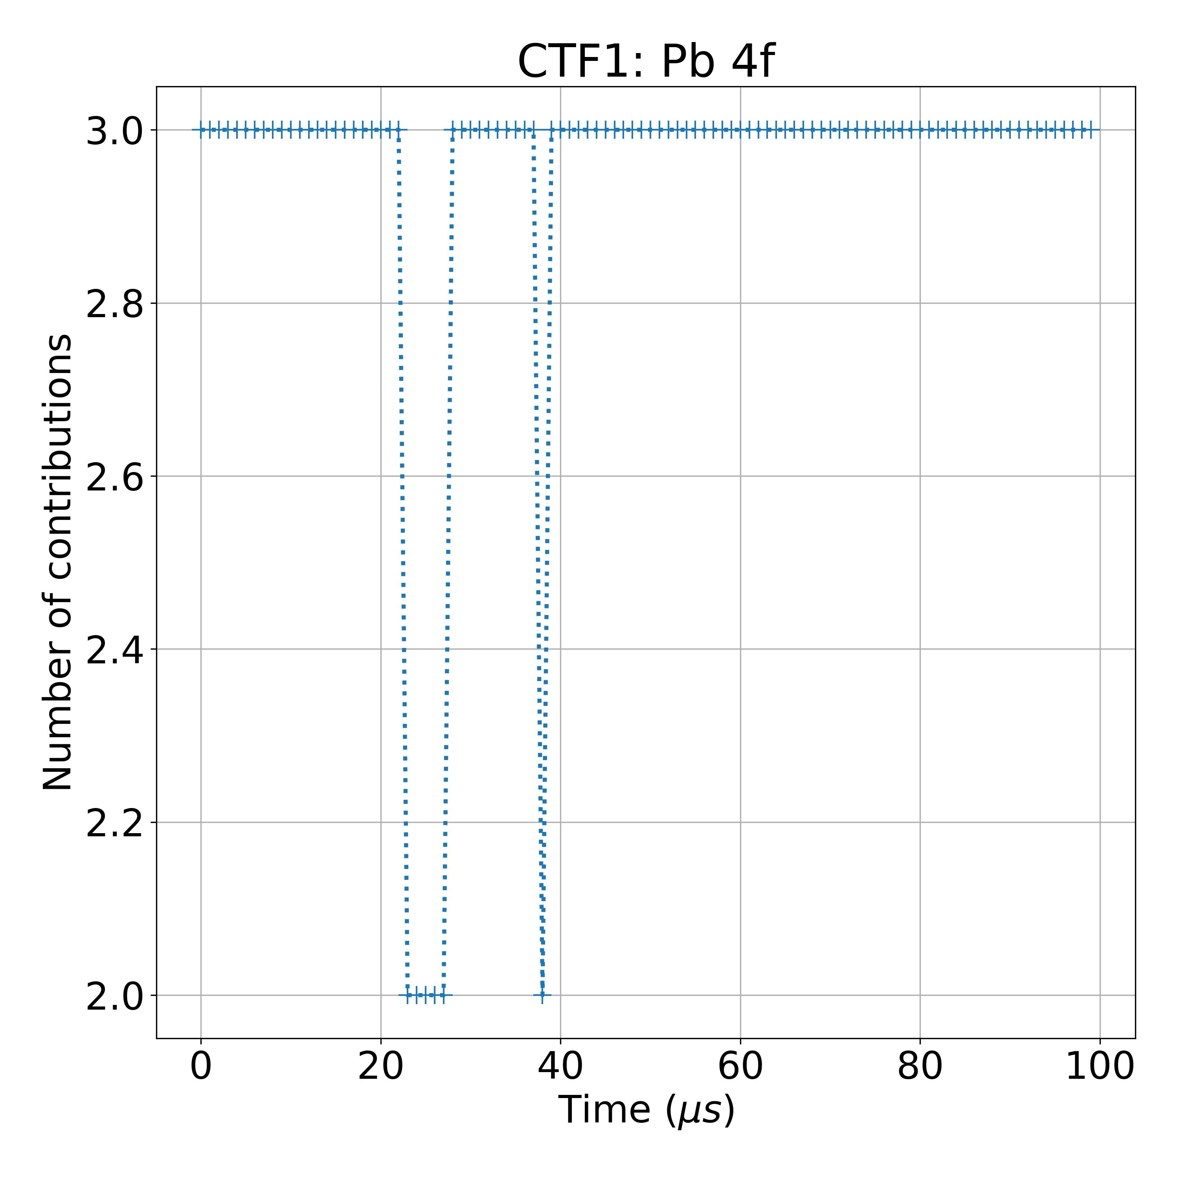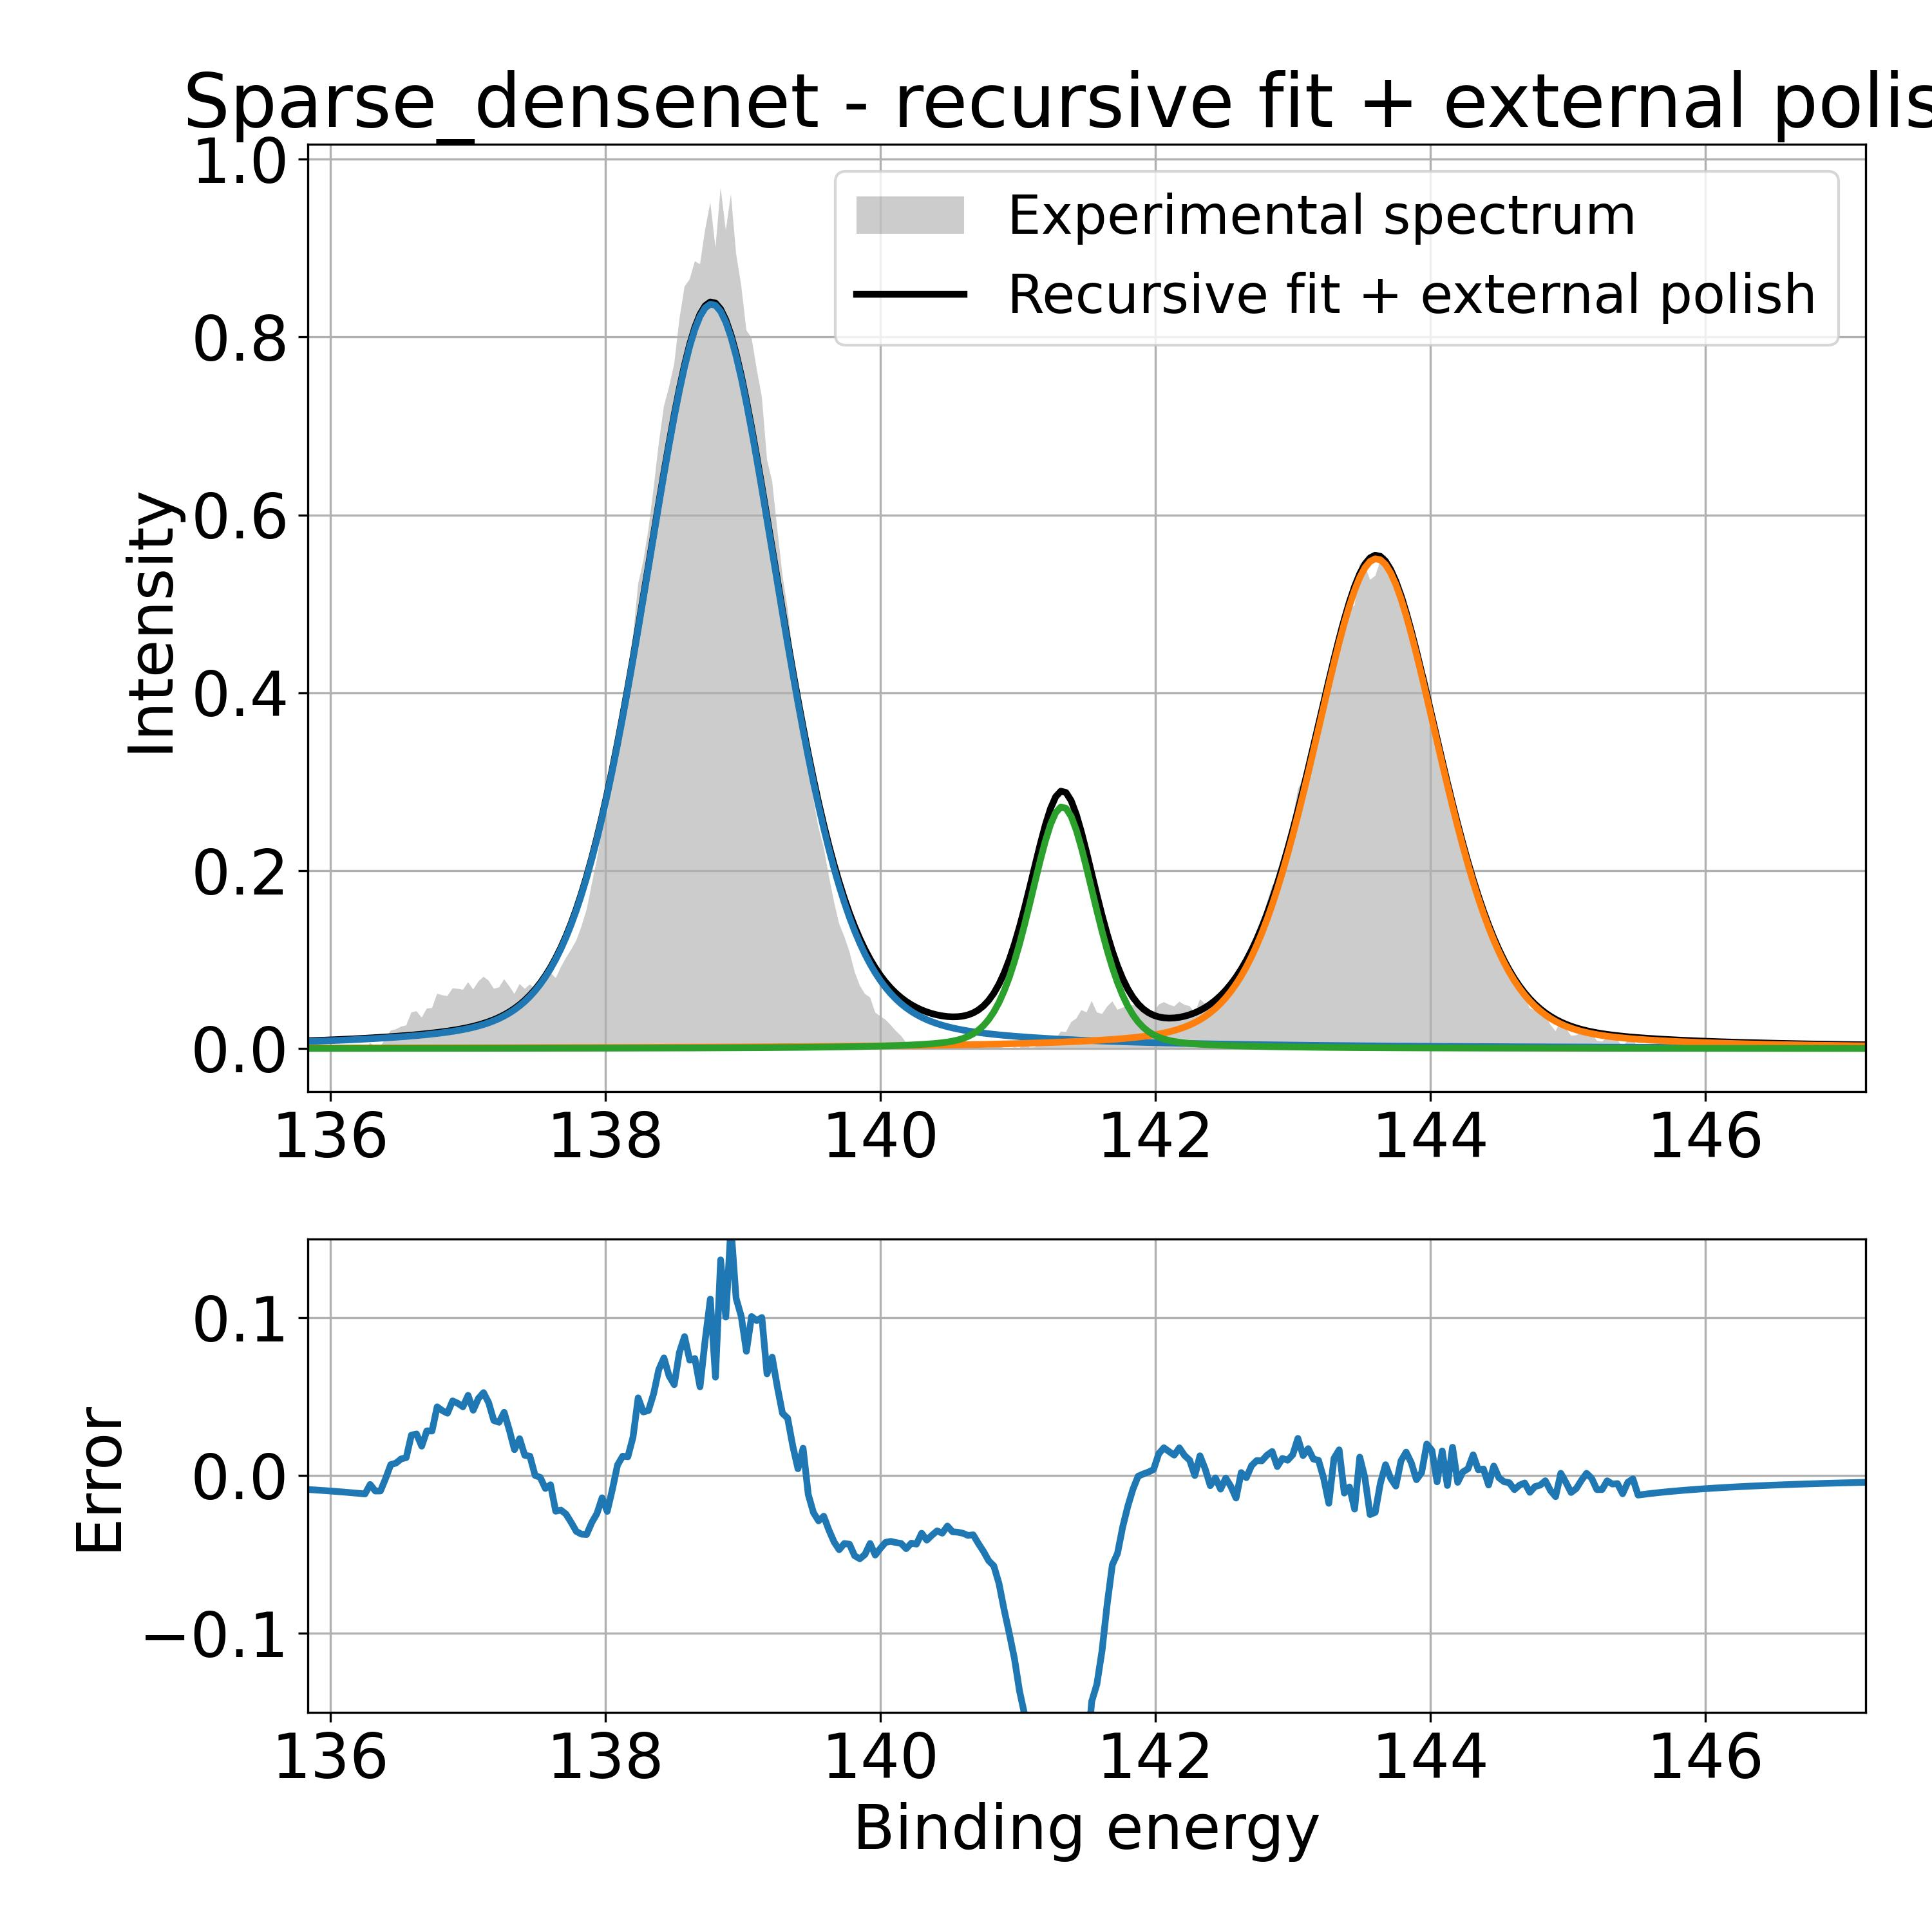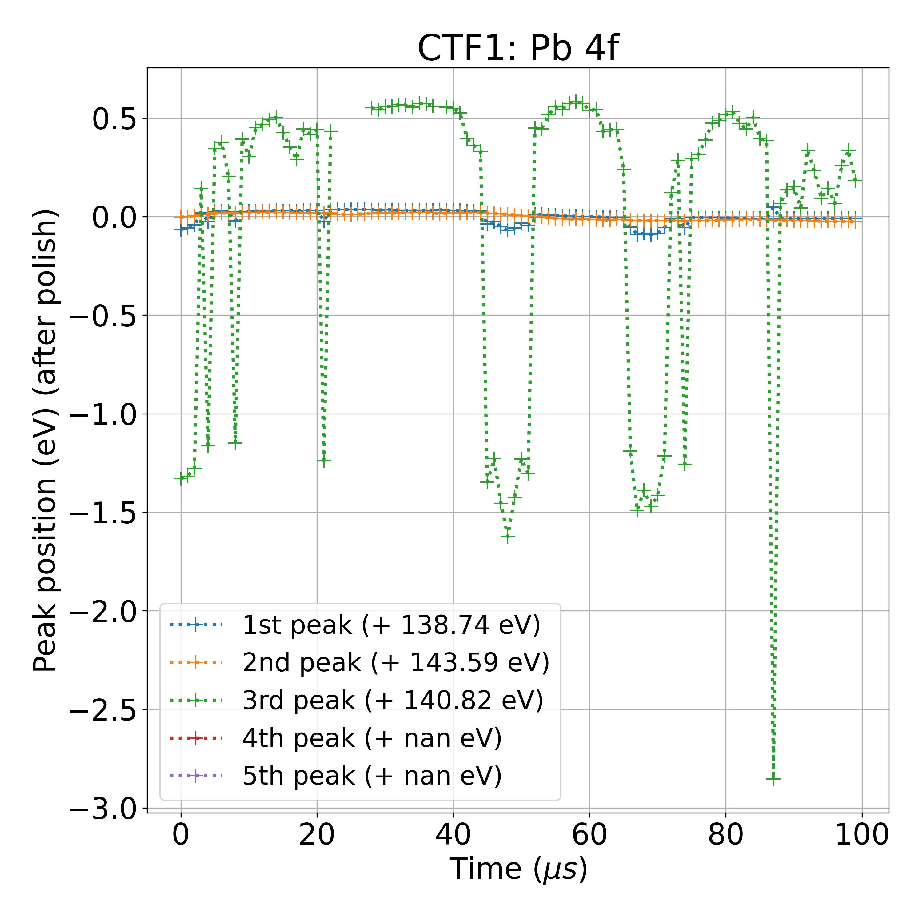

LeNet

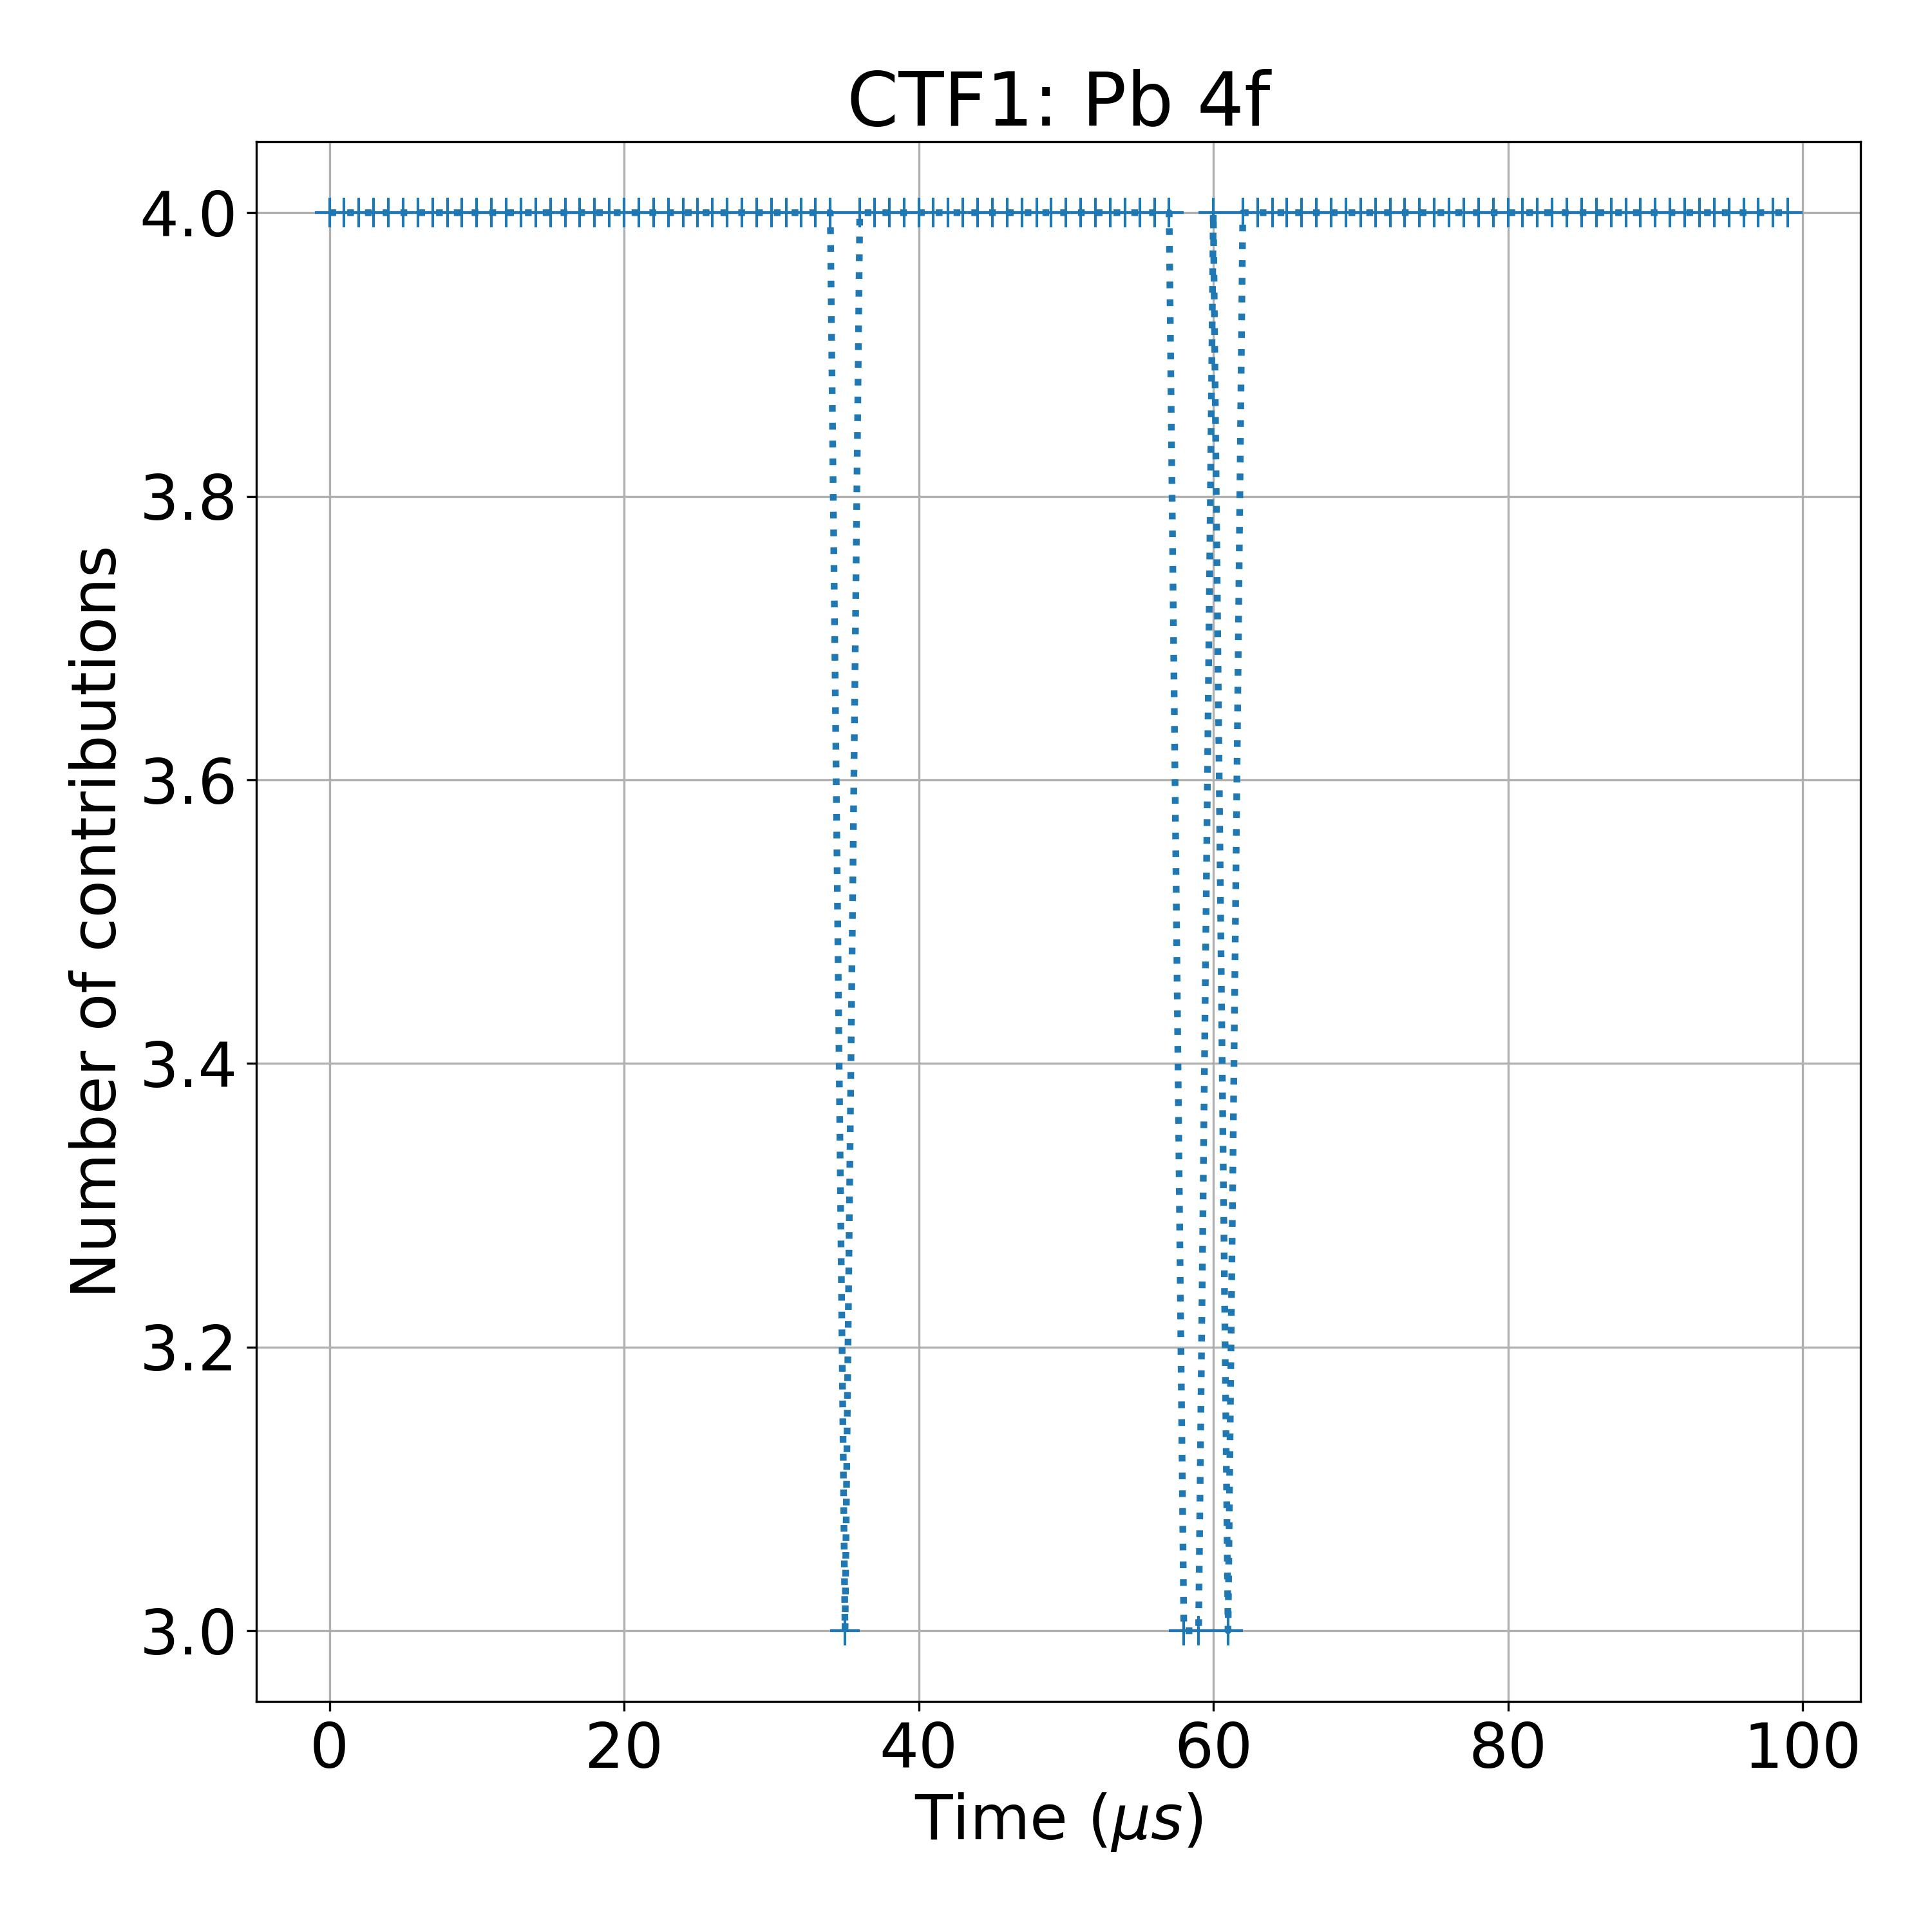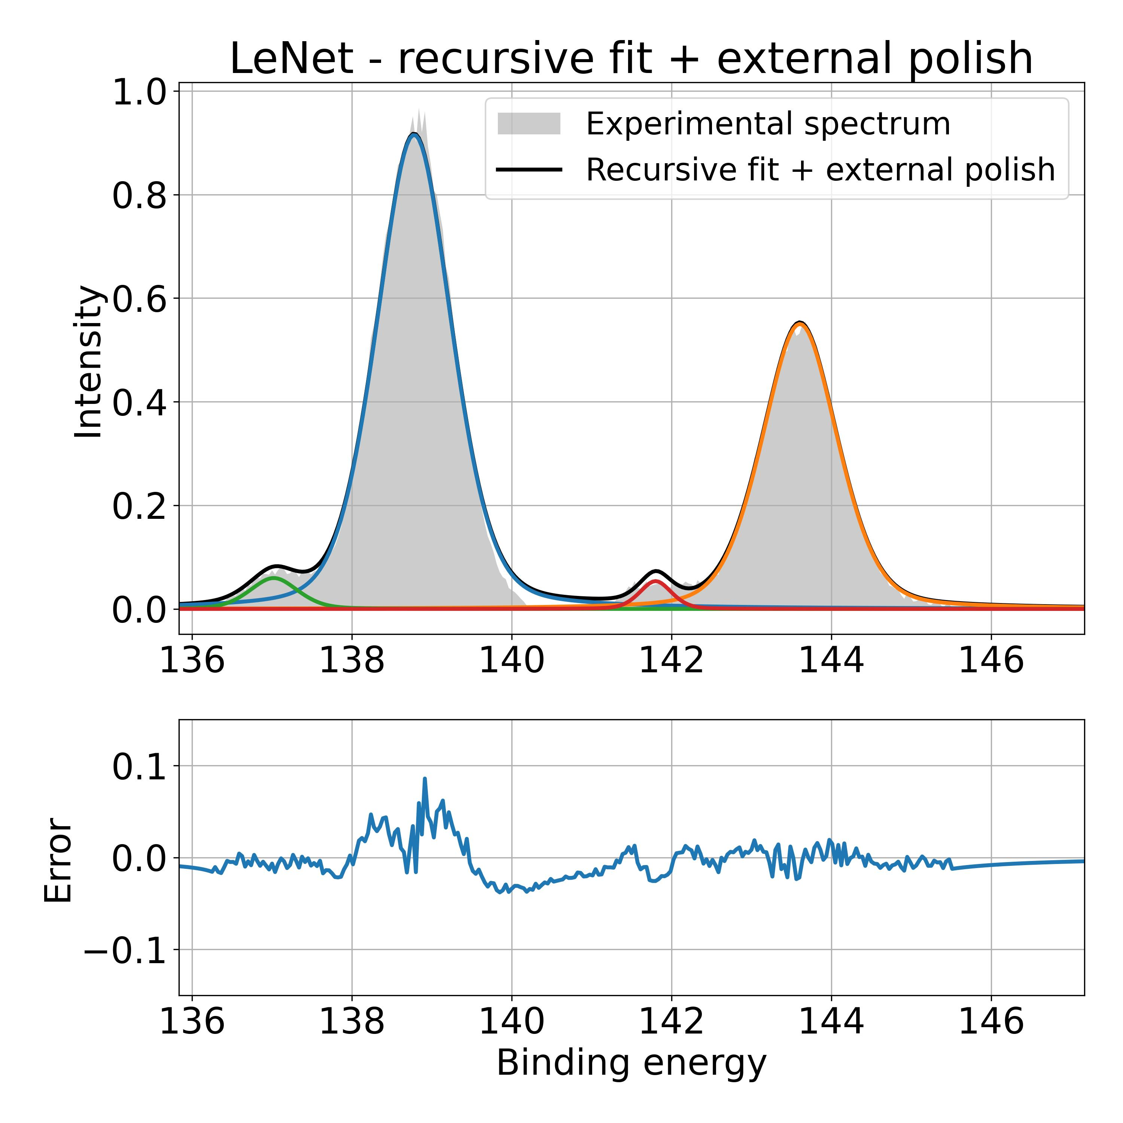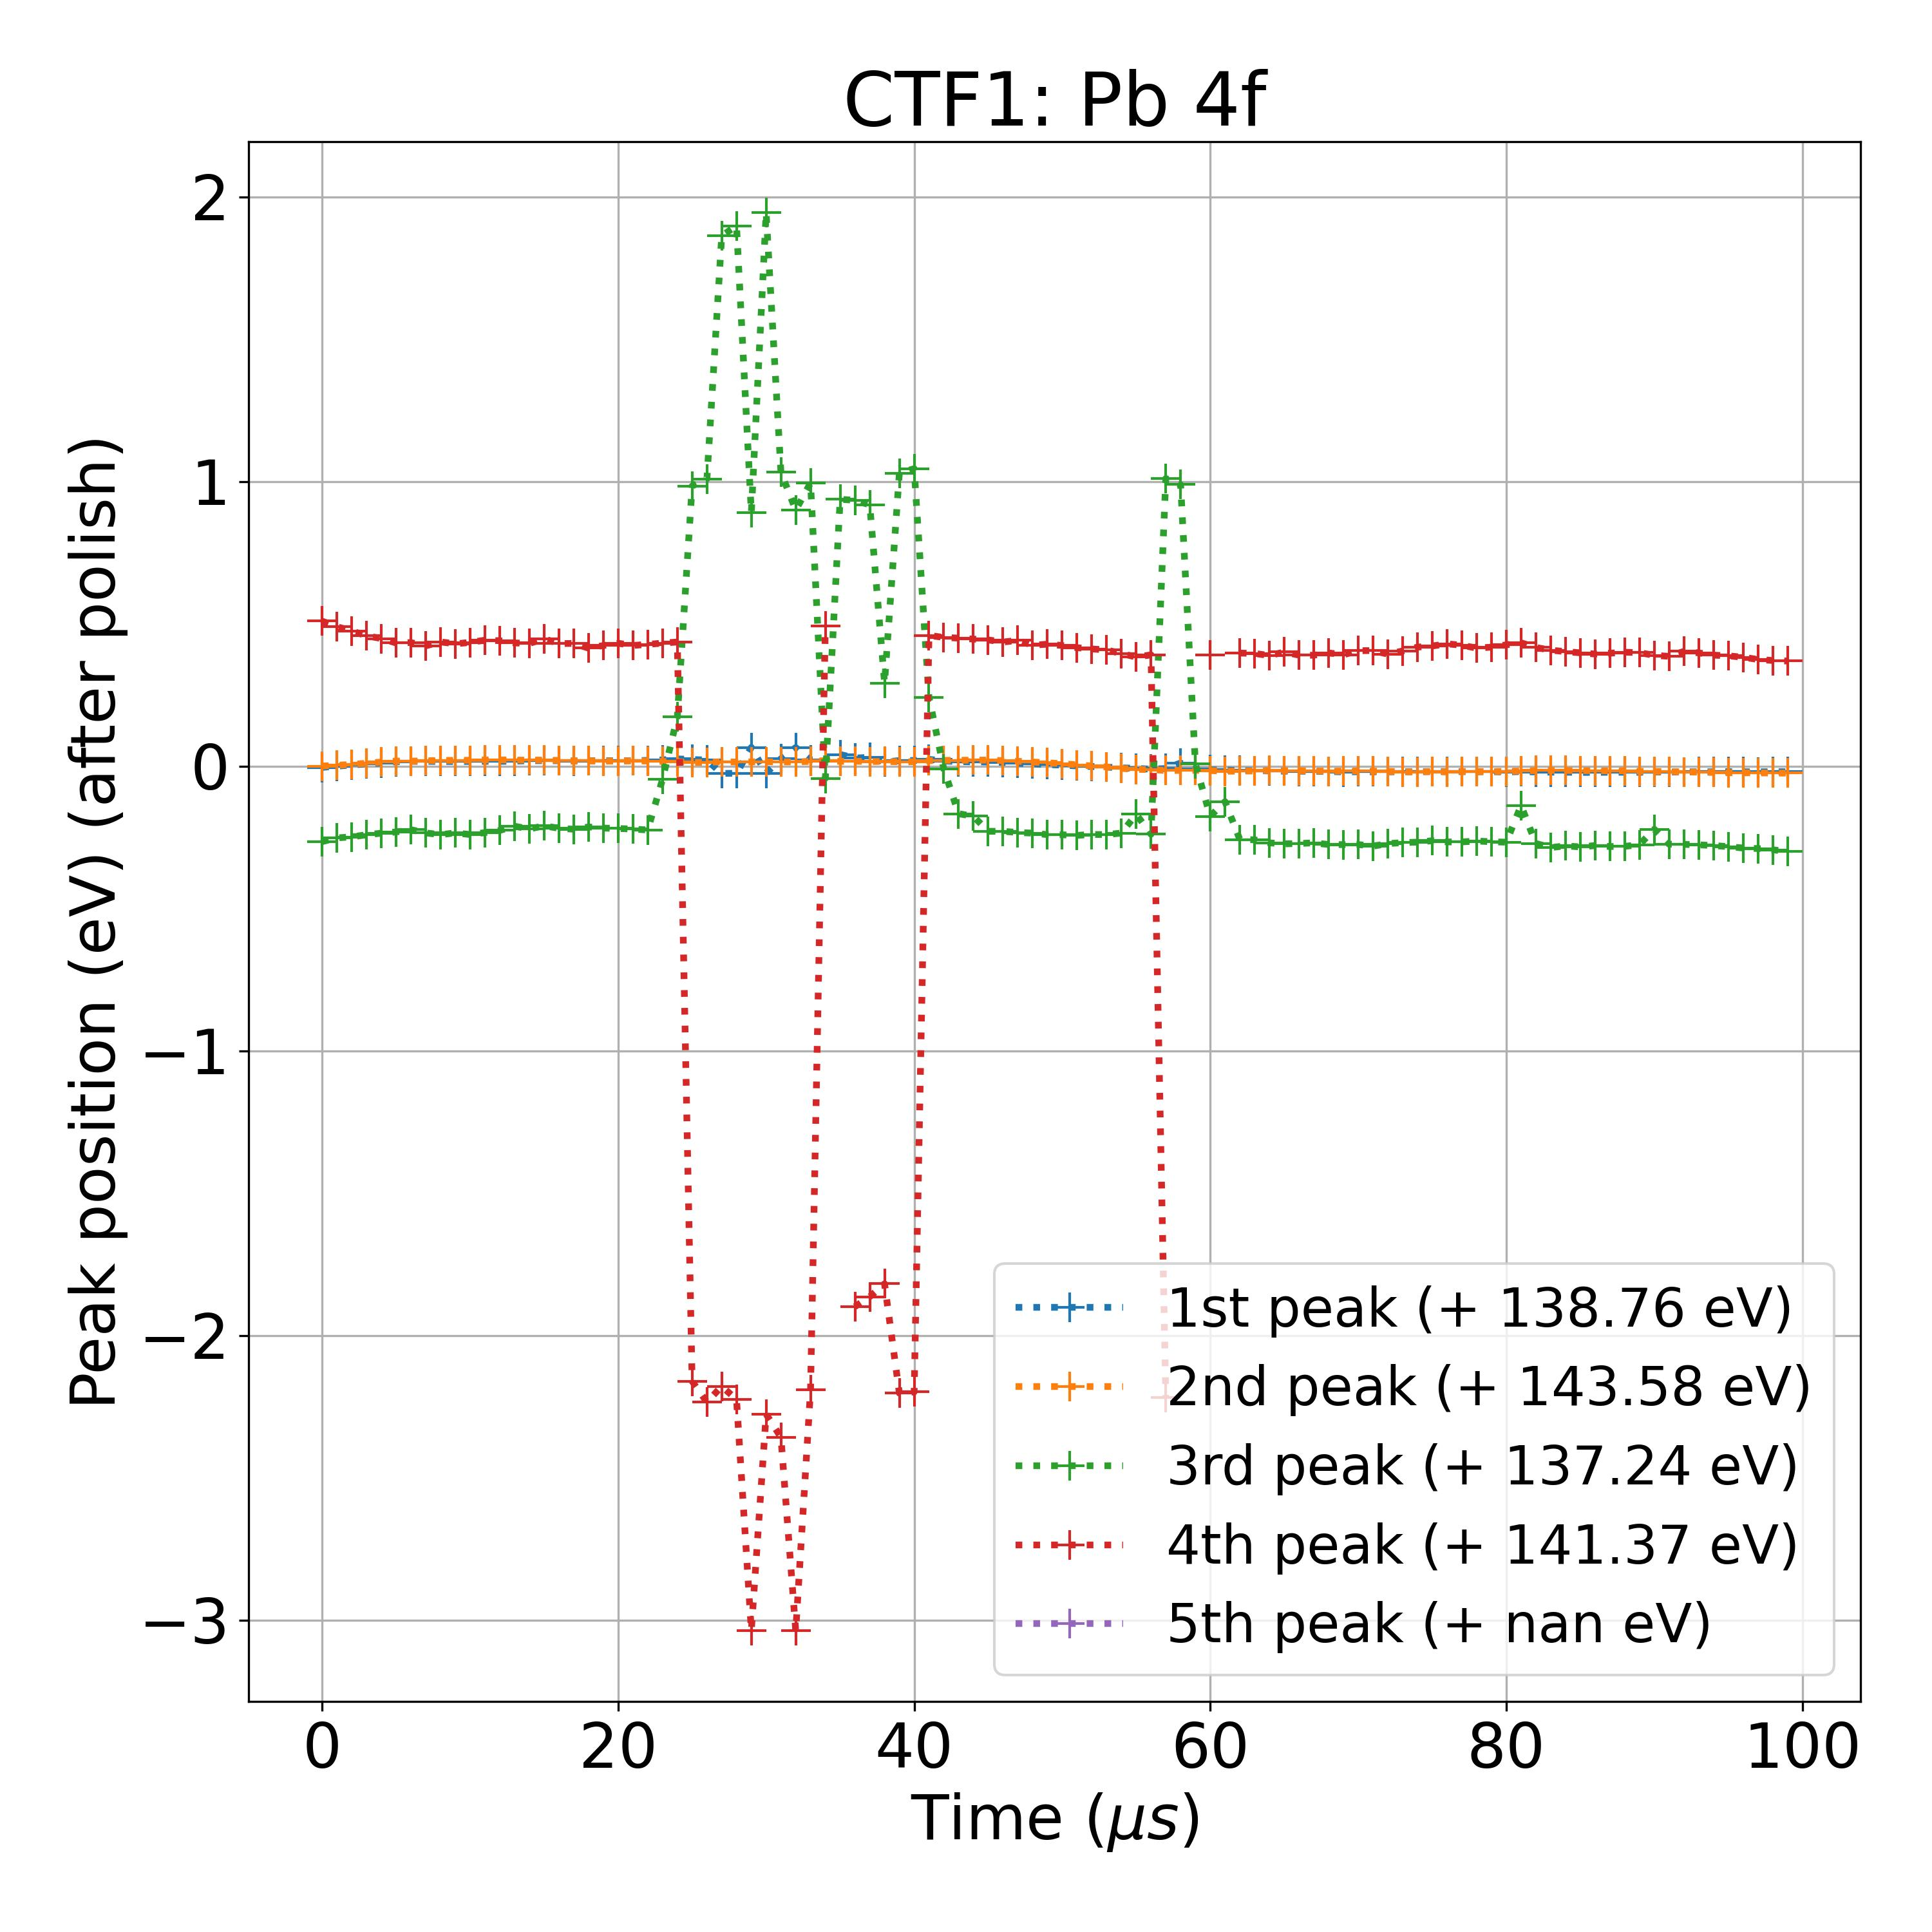

**Database C**

Sparse densenet

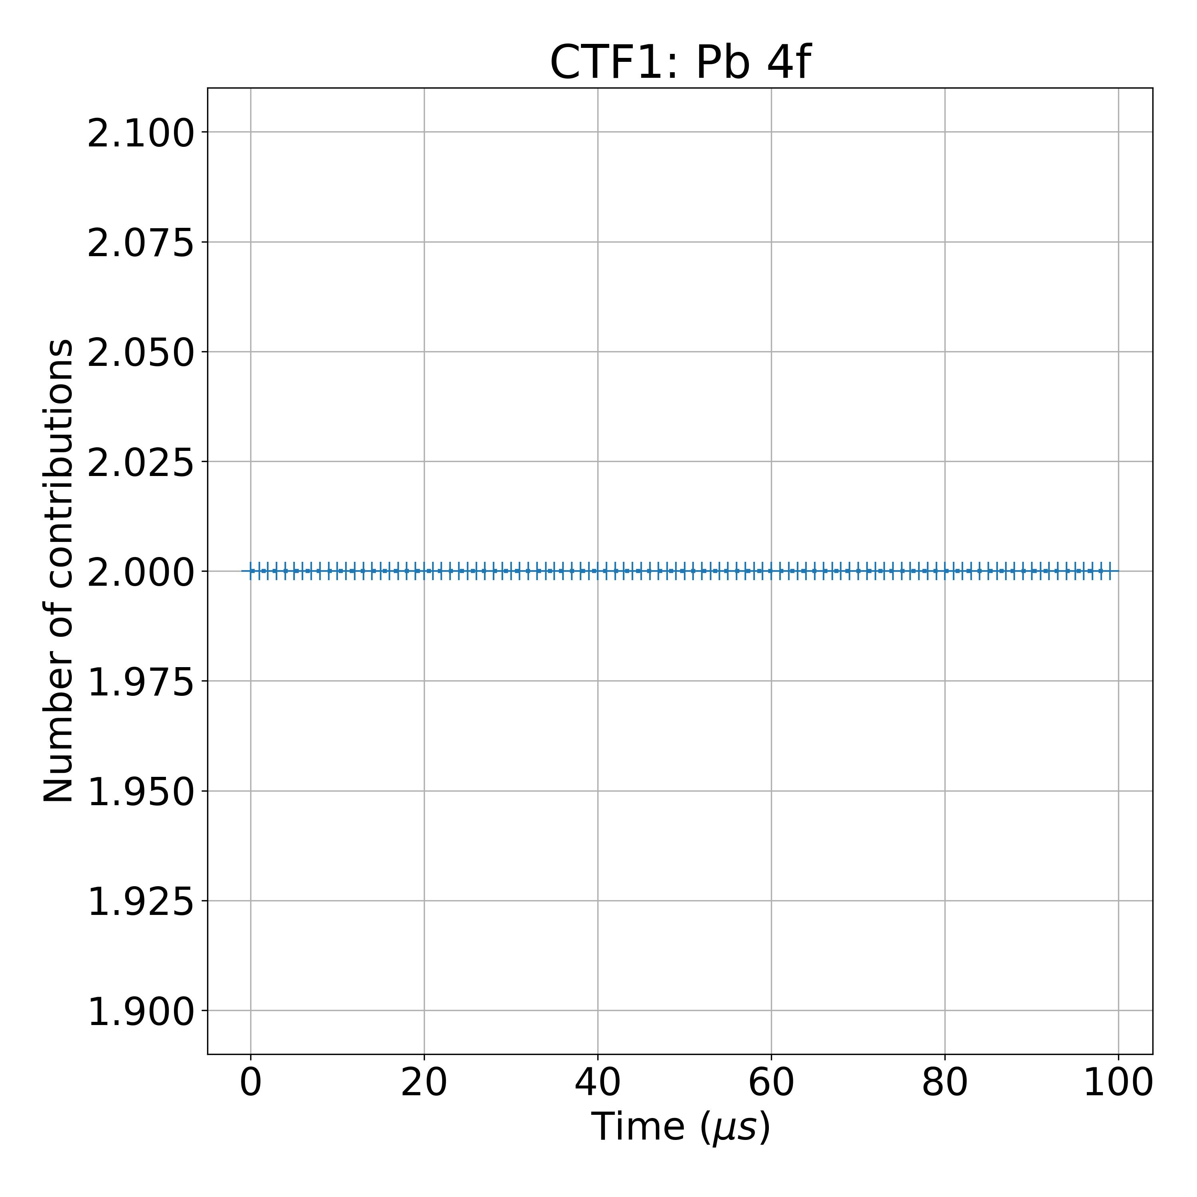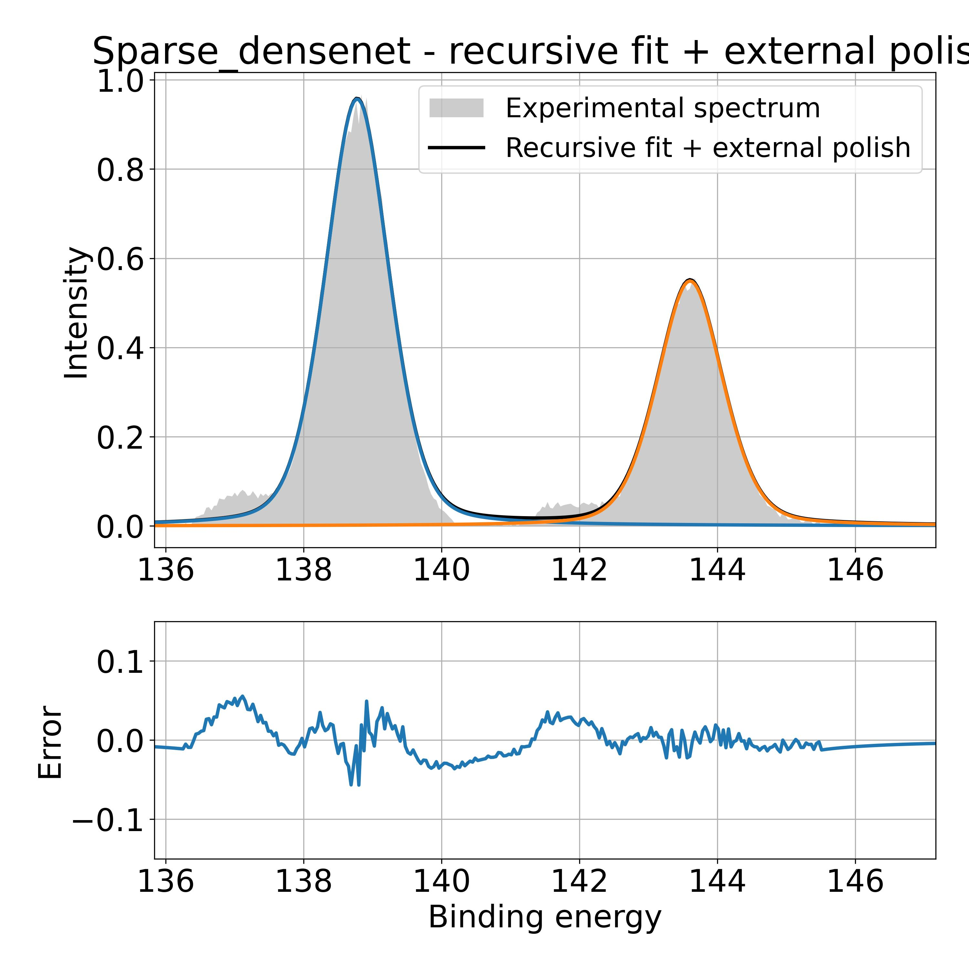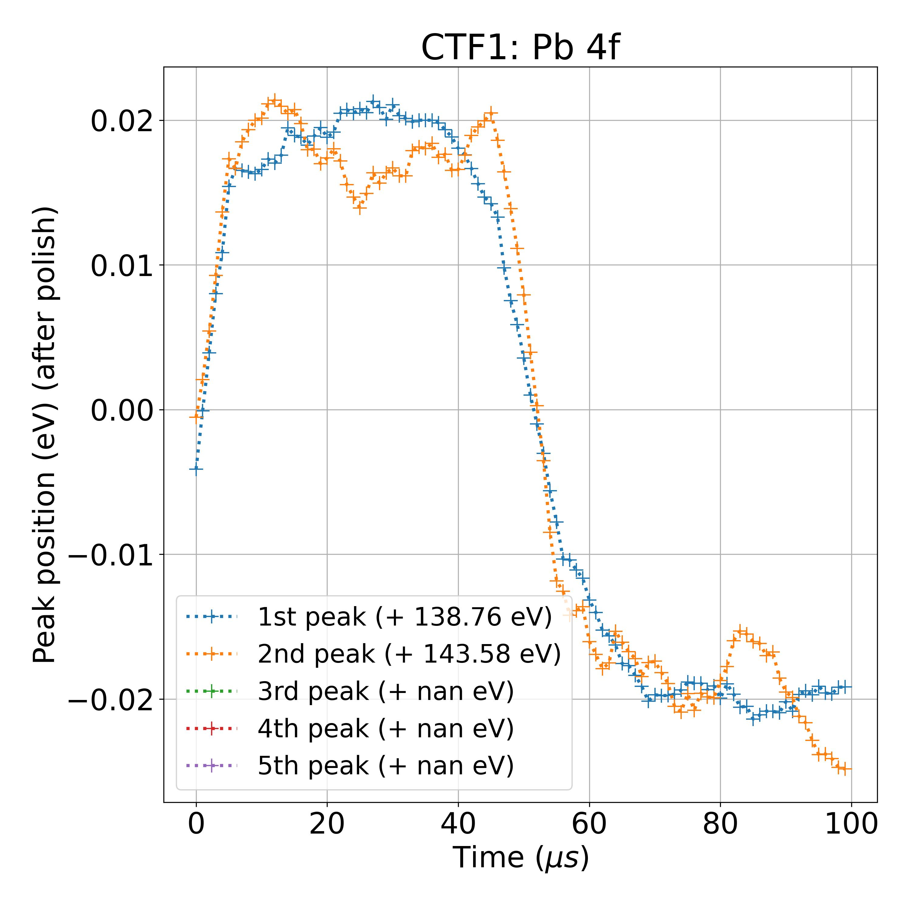

LeNet

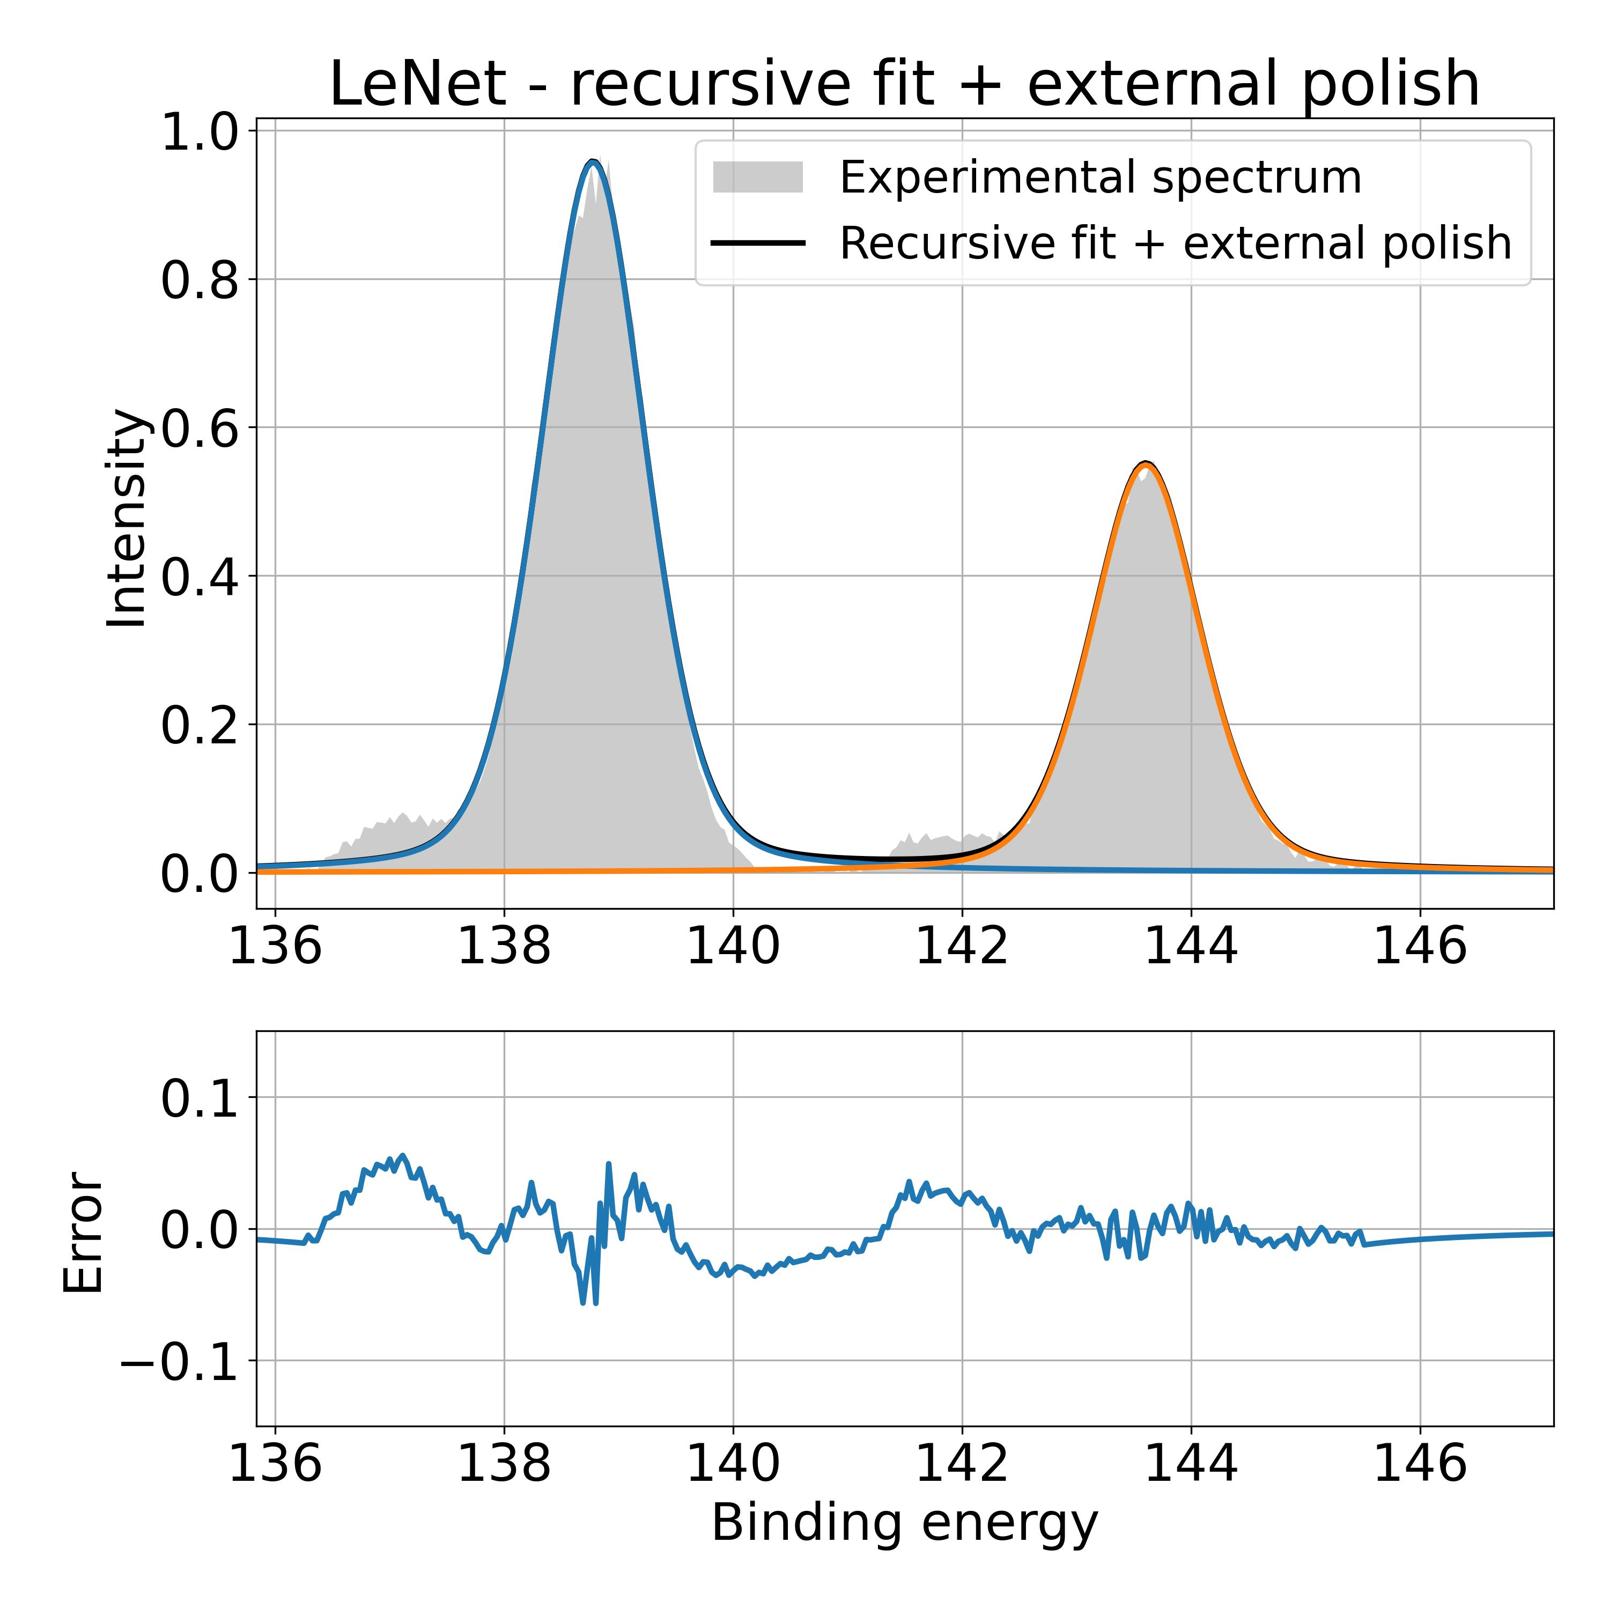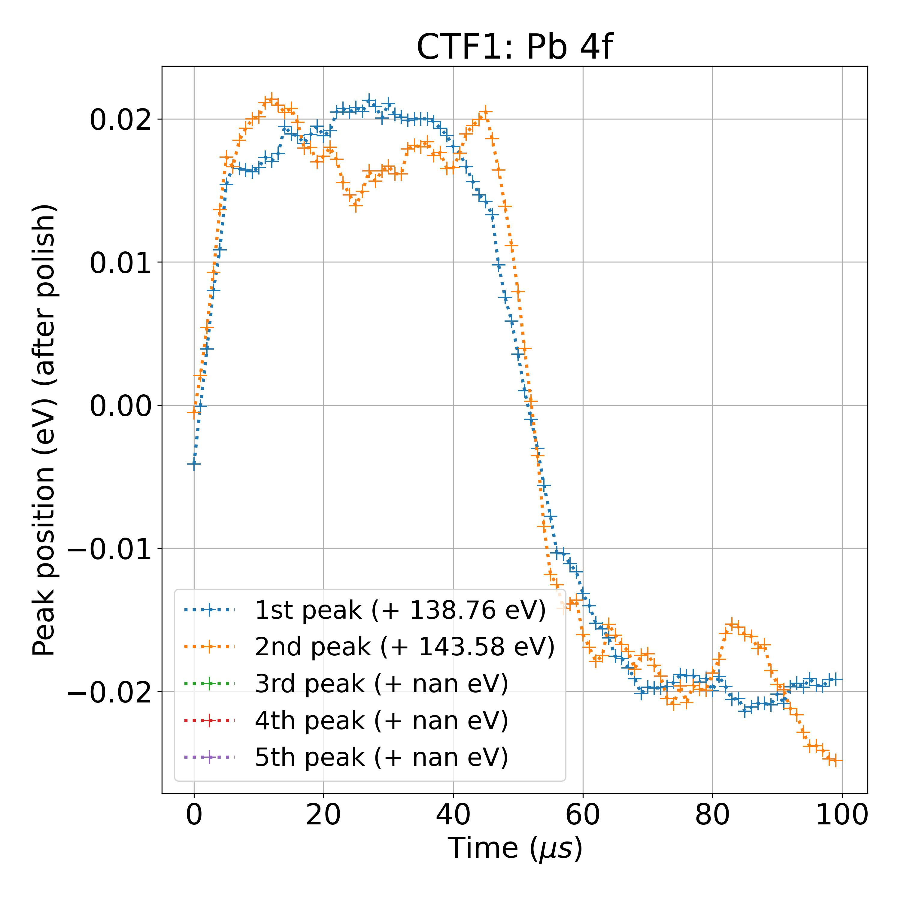

**Database C** – recursive fit forced to 4 contributions:

Sparse densenet

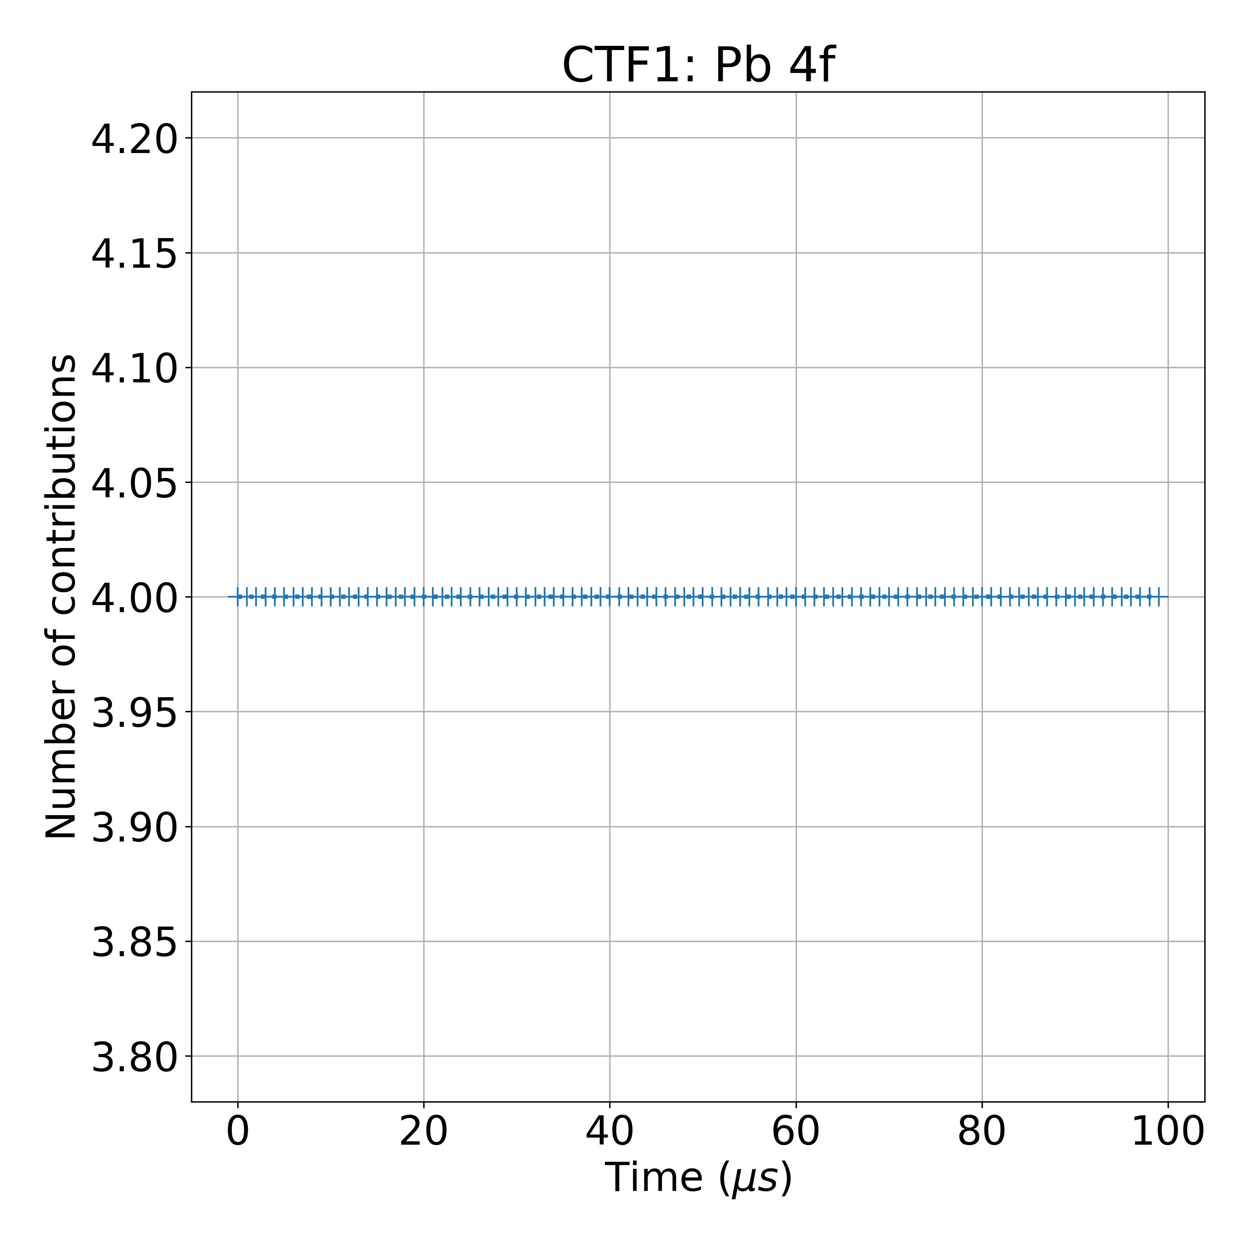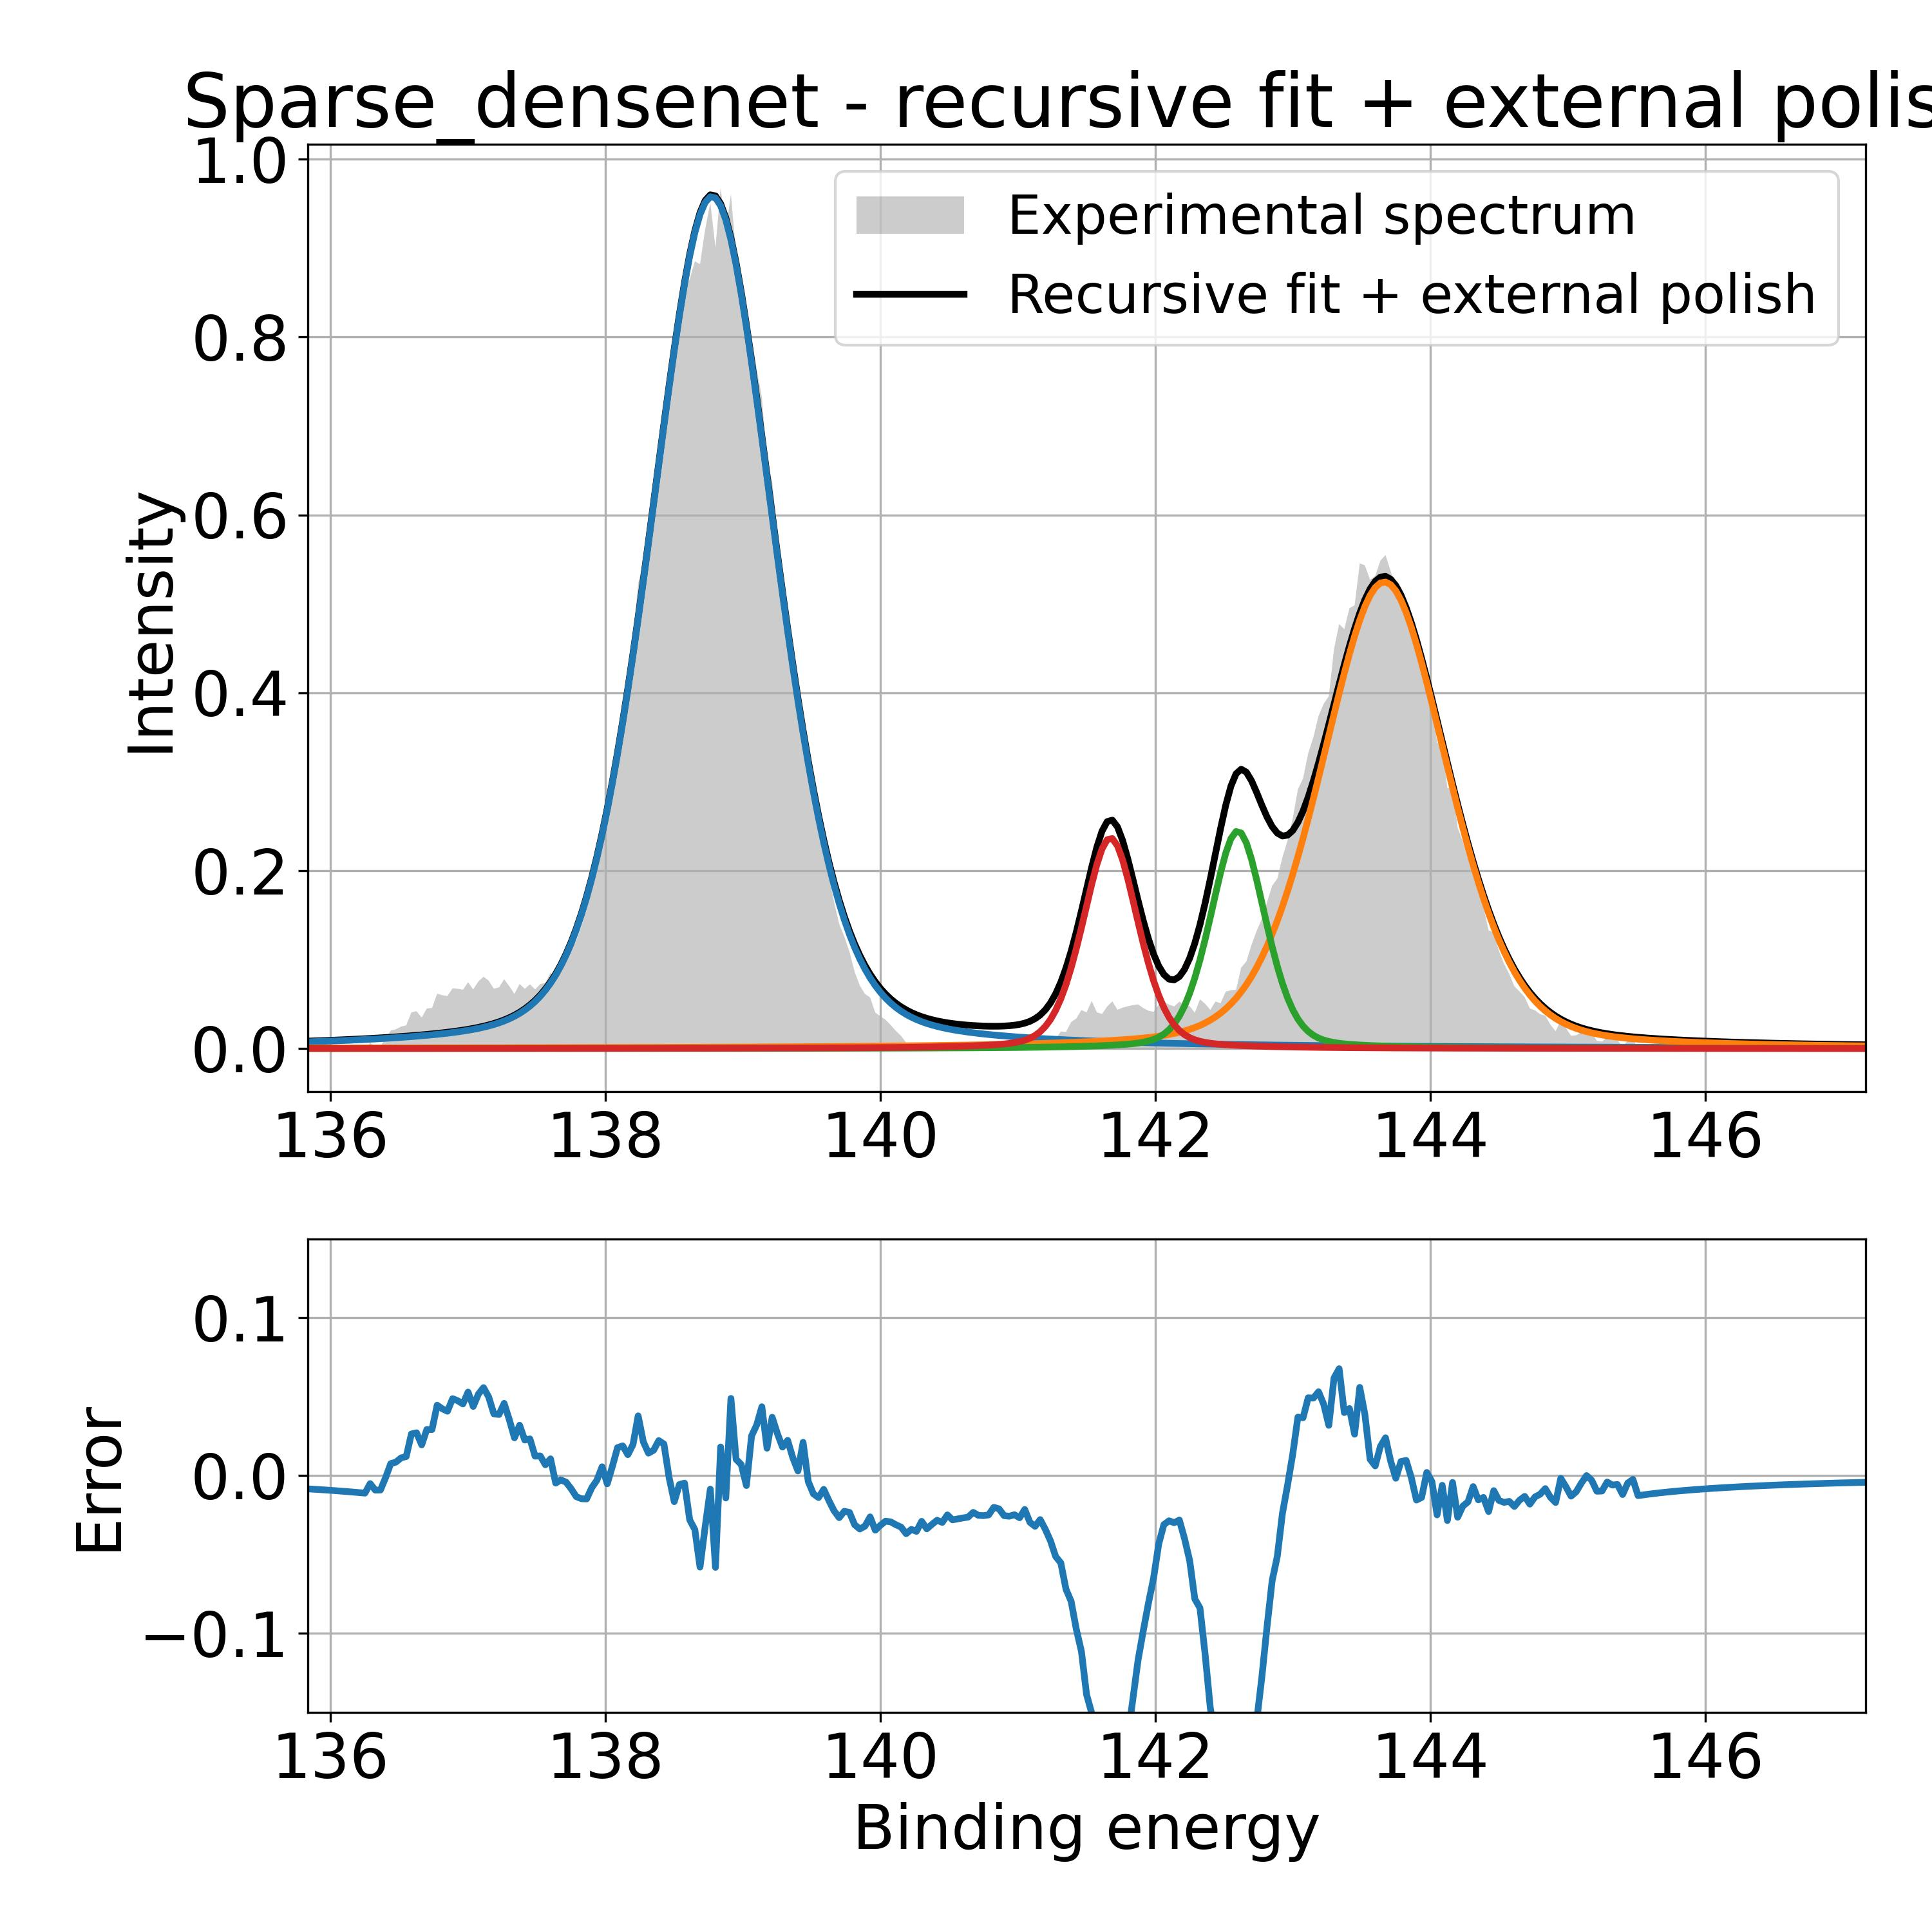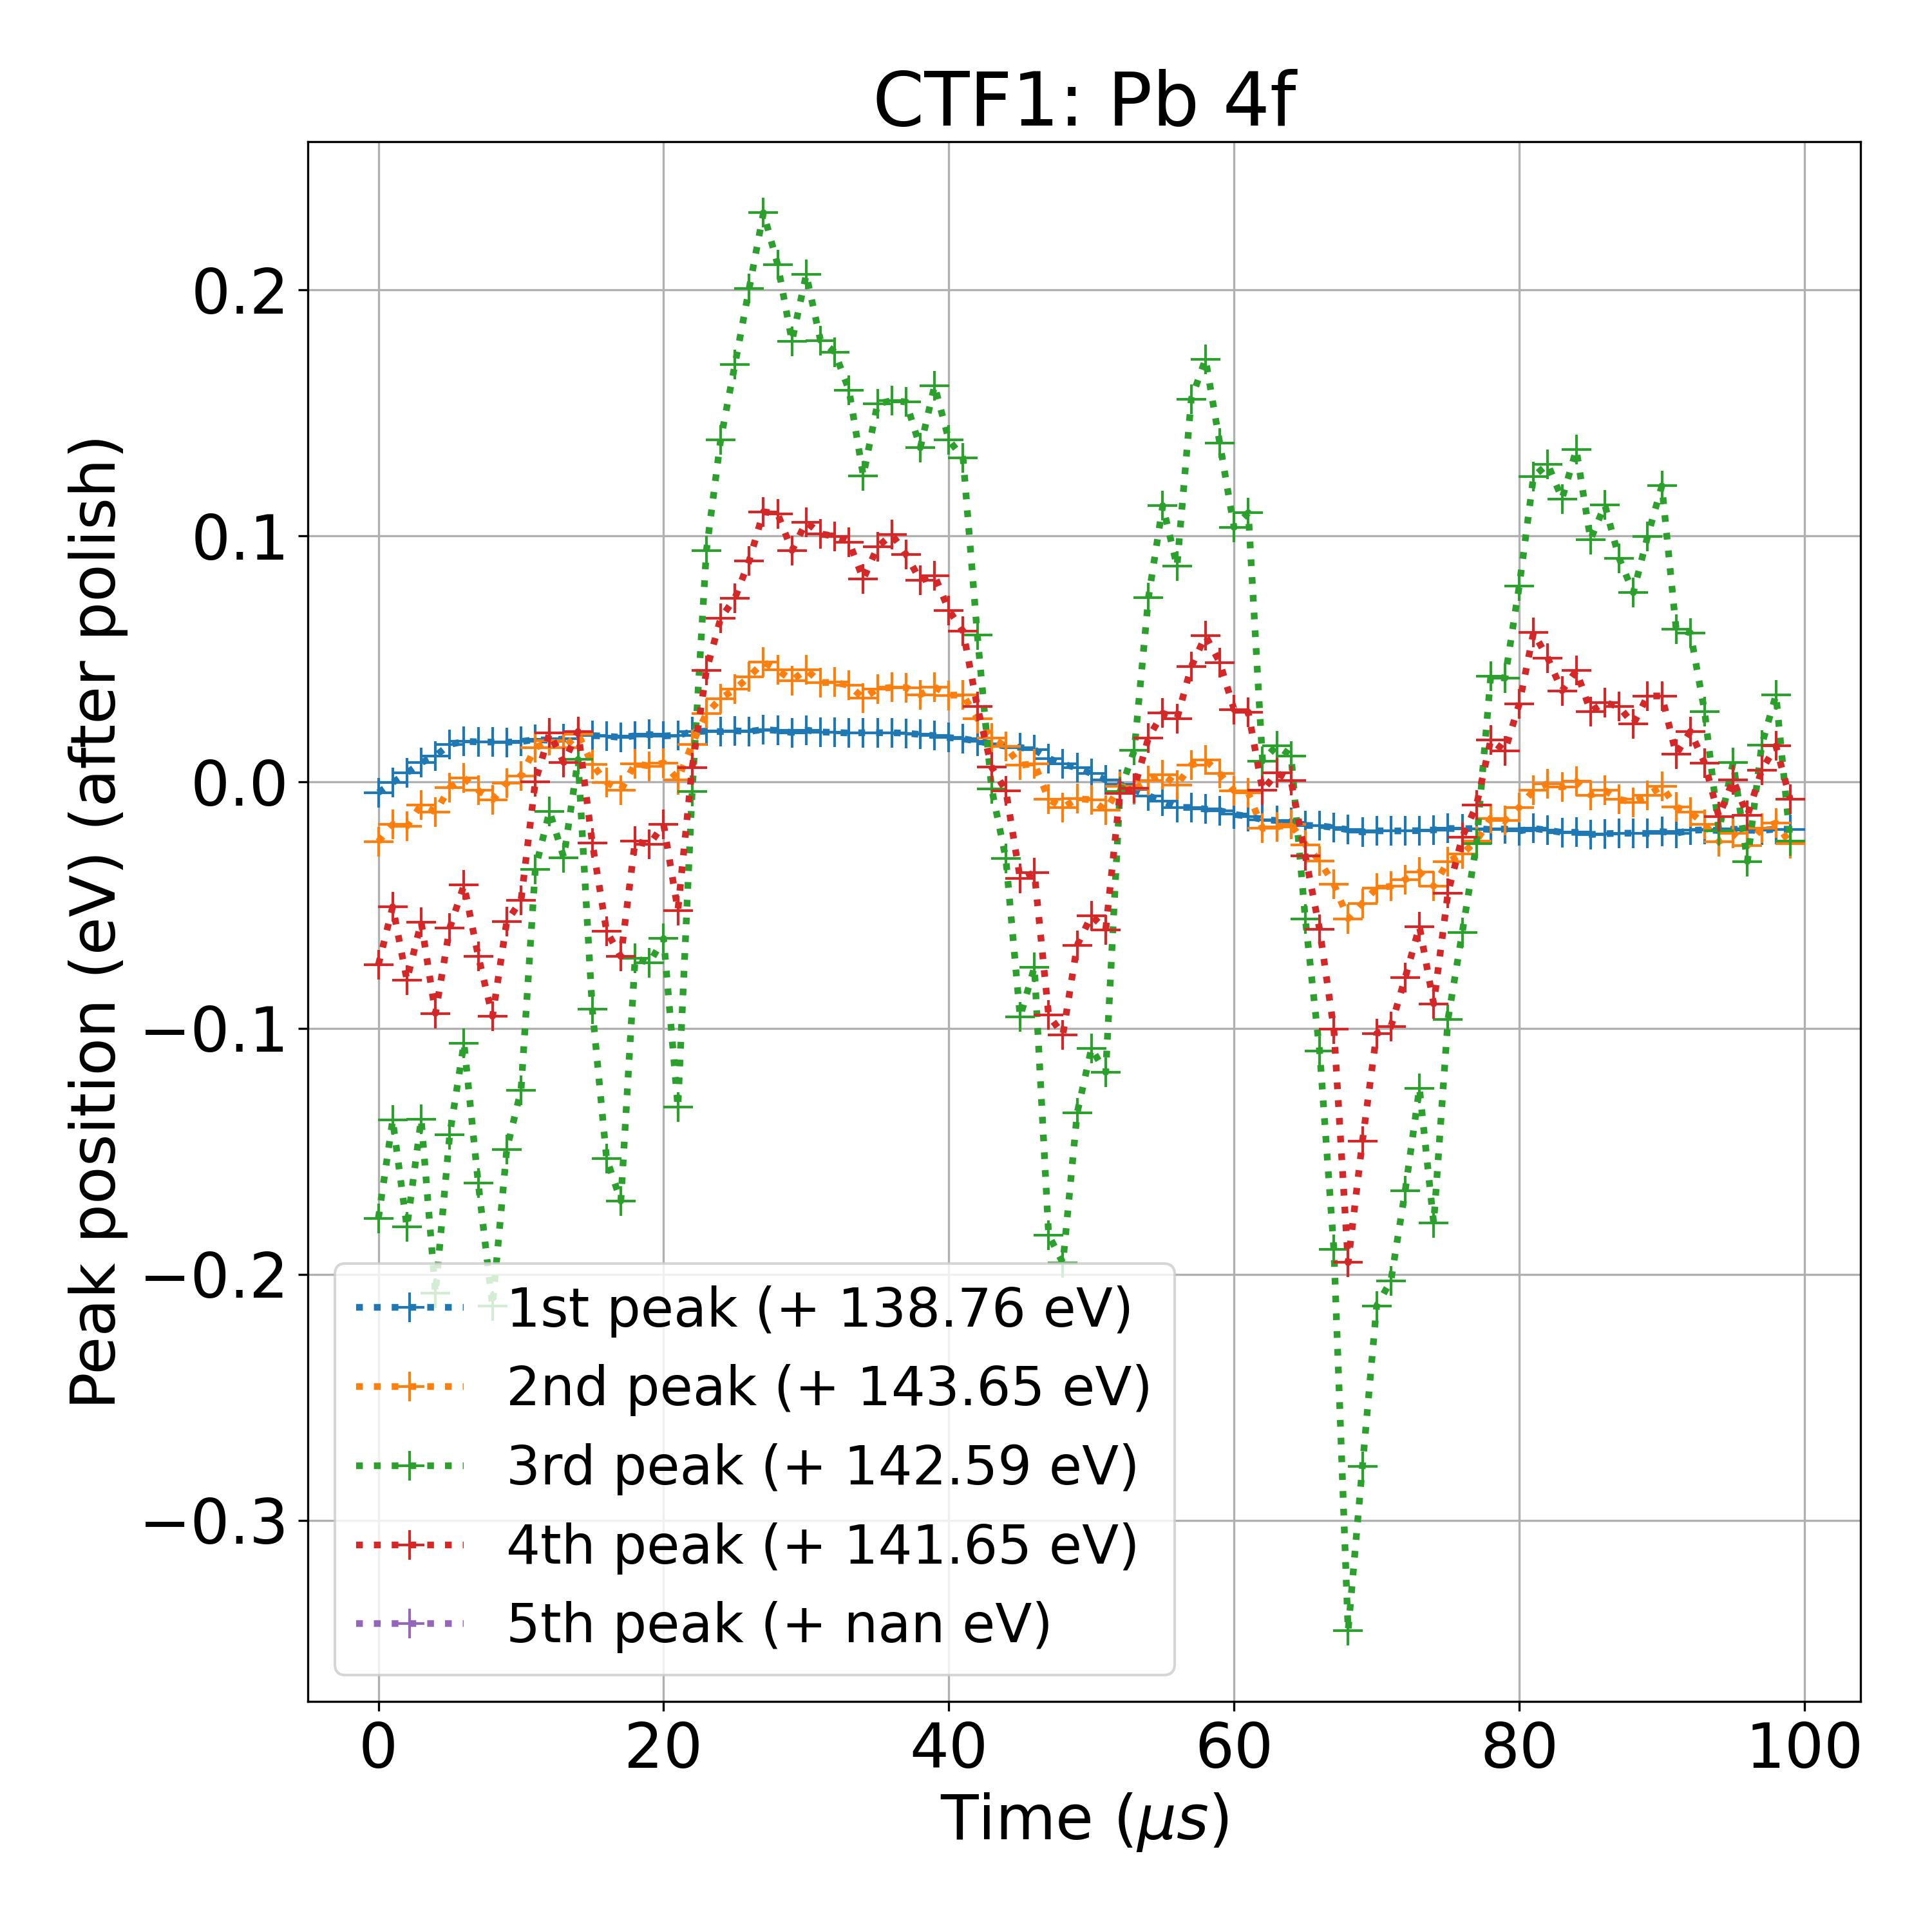

LeNet

